|  |  |
| --- | --- |
| \\VFILERDPI\DPI-Home\OBRIENR2\My Documents\Downloads\PP logo.jpg | Central Coast Council Logo |
| **PANEL ASSESSMENT REPORT**  HUNTER AND CENTRAL COAST REGIONAL PLANNING PANEL | |

|  |  |
| --- | --- |
| PANEL REFERENCE & DA NUMBER | PPSHCC -87  DA/1163/2021 |
| PROPOSAL | Redevelopment of fire damaged Registered Club and associated parking, landscaping and other works |
| ADDRESS | 2-4 Park Road, The Entrance, Lot 1 DP 180642, Lot 1 DP 406038,  10 Warrigal Street, The Entrance, Lot 50 DP 661107 |
| APPLICANT | Mingara Leisure Group C/- ADW Johnson Pty Ltd |
| OWNER | Central Coast Council (2-4 Park Road) &  Mingara Recreation Club Ltd (10 Warrigal Street) |
| DA LODGEMENT DATE | 3 September 2021 |
| APPLICATION TYPE | Development Application |
| REGIONALLY SIGNIFICANT CRITERIA | Clause 3(b) Schedule 6 of the SEPP (Planning Systems) 2021. Council owned land with CIV exceeding $5 million |
| CIV | $9,663,059 (excluding GST) |
| CLAUSE 4.6 REQUESTS | N/A |
| KEY SEPP/LEP | * *State Environmental Planning Policy (Resilience and Hazards) 2021* * *State Environmental Planning Policy (Industry and Employment) 2021* * *State Environmental Planning Policy (Planning Systems) 2021* * *Wyong Local Environmental Plan 2013* * *Central Coast Local Environment Plan 2022* * *Draft Remediation of Land SEPP;* |
| TOTAL & UNIQUE SUBMISSIONS | 1 |
| DOCUMENTS SUBMITTED FOR CONSIDERATION | Architectural Plans dated Jan 2022  Landscape Plans dated Jan 2022  Amended Acoustic Report Jan 2022  Amended Traffic and Parking Assessment Jan 2022  Operation Security Plan of Management Plan V.2  CPTED Report July 2021  Assessment of LED Advertising Sign report Jan 2022  Waste Management Plan Dec 2021  Correspondence ADW Johnson dated Jan 2022 |
| SPECIAL INFRASTRUCTURE CONTRIBUTIONS (S7.24) | N/A |
| RECOMMENDATION | Deferred Commencement |
| DRAFT CONDITIONS TO APPLICANT | YES |
| SCHEDULED MEETING DATE | 20 July 2022 |
| PREPARED BY | Principal Development Planner – North (S Pendergast) |
| DATE OF REPORT | 6 July 2022 |

**EXECUTIVE SUMMARY**

* The application seeks approval for redevelopment of the existing fire damaged club and associated parking landscaping and other works.
* The site has a history of use as a bowling club dating back to 1939. In March 2020, a significant fire damaged the two-storey section of the club building forced the club to cease trading. Demolition works were approved in January 2021 for almost the entire building of the Registered Club due to the fire damage.
* Council has resolved to reclassify and sell the land upon which the current club lease sits. However, to date the land remains community land and the land is part of the larger lot containing Taylor Park.
* The site is zoned RE1 Public Recreation Zone under the Wyong Local Environmental Plan 2013 and a ‘registered club’ and ‘recreation facility (outdoor)’ are both permissible uses within the zone.
* A number of issues were raised in relation to the proposed development in initial correspondence forwarded to the applicant in November 2021. These issues included:

parking provision; compatibility with the adopted plan of management and public interest; acoustic impacts, amenity impacts from illuminated signage and light spill, design treatments elevations, waste management, social impacts, car park design, hours of operation, encroachments, food compliance, and submission concerns.

* Amended plans and information were provided for the assessment and the property at 10 Warrigal Street was included within the subject site. The proposal is considered satisfactory subject to conditions including deferred commencement conditions to link the sites containing the parking to the subject site to address a parking shortfall; for revised landscape plans; to the reduce the size of the LED plinth sign; and for the registration of a plan to address encroachments. Other conditions have been recommended to address amenity impacts and operational aspects of the development.

* The application is referred to the Hunter and Central Coast Planning Panel (‘the Panel’) as the development is ‘*regionally significant development’*, pursuant to Clause 3(b) Schedule 6 of the SEPP (Planning Systems) 2021. Council owned land with CIV exceeding $5 million

Following a detailed assessment of the proposal, pursuant to Section 4.16(1)(b) of the *EP&A Act*, DA/1163/2021is recommended for approval subject to the conditions contained at **Attachment A** of this report.

1. **THE SITE AND LOCALITY**
   1. **The Site**

The property known as 2-4 Taylor Street is owned by Central Coast Council, comprises 2 lots and is approximately 2.36 hectares in area. The property contains Taylor Park sports ground (known as Shore Park) with associated parking and amenities at the northern end and The Greens bowling club at the southern end. The land is designated as community under the *Local Government Act 1993.*

The part of the property known as 2-4 Taylor Street that is occupied by the club and leased from Council is approximately 6,941m² in area. It is this smaller leased part of the larger lot which is to be referred to as the subject site. The application was amended to include 10 Warrigal Street (which is privately owned by Mingara) and contains an existing car park currently used by the club. The club is not identified as a heritage item.

The subject site has a frontage to both Warrigal Street (approx. 140m) Park Road (over 65m). There is no significant vegetation on the site which is relatively flat as most of it is occupied by existing bowling greens. The club building has recently been burnt down and following demolition works only remnant frame structures, a façade wall and bowling greens remain on the site.

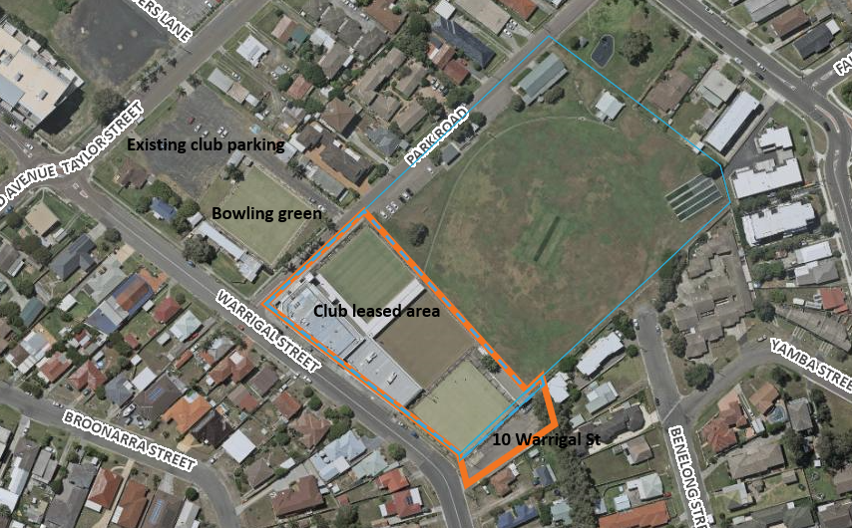

Above: Amended subject site (orange) and 2-4 Park Road (blue), club leased area (dotted blue)

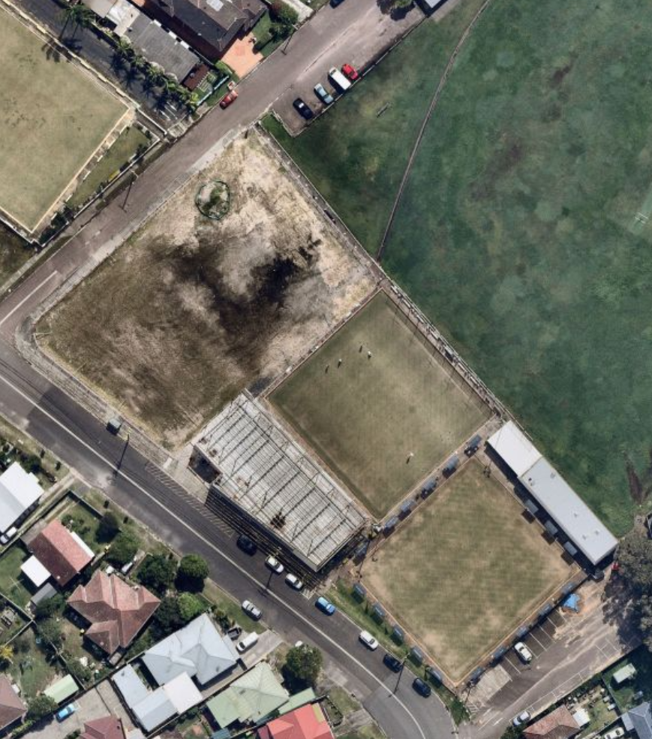

Above: Aerial view of site following demolition of the fire damaged building

* 1. **The Locality**

1. **THE PROPOSAL AND BACKGROUND**

The surrounding context of the site is one and two storey, low to medium residential density development although some multi-storey residential buildings are visible from the site in the distance.

Surrounding the site to the east ( along Warrigal Street) are single storey residential dwellings. Opposite the site to the south in Warrigal Street are dwelling houses with garden frontages, generally single storey in scale. The architectural style of the low scale residential is modest ranging from traditional fibro cottages to brick and tile dwellings, all with pitched roofs. Common elements in the streetscape are the use of low scale brick front fences, and other fencing materials, with low scale vegetated gardens.

Opposite the site to the west along Park Road (and bounded by Taylor and Warrigal Streets) is land that forms part of the existing approved club facilities and includes a bowling green and a large at grade carpark (approx. 60 spaces) and driveway access. The car park is approved for use as parking associated with the club.

The site is located at the south-eastern end of The Entrance Town Centre. Although residential zones and activity surrounds the site, the Lakeside Shopping Centre is located within 150m radius of the site to the north west and the beach is 500m to the east. The area is traditionally a holiday destination. There are a number of higher density residential buildings located to the north and west of the site in closer proximity to the town centre and commercial areas.

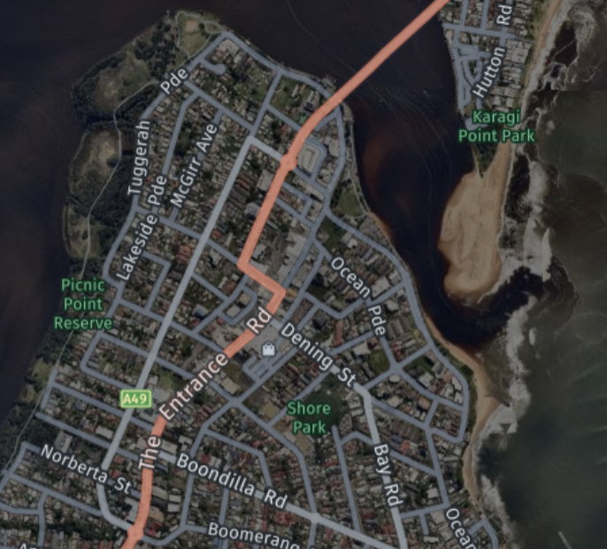

Above: The site broader locality

* 1. **The Proposal**

The proposal seeks consent for the redevelopment of fire damaged Registered Club known as The Greens. The proposal includes associated signage and car parking and other works. The proposed redevelopment is on a much smaller area and a reduced scale compared to the original approved club and facilities.

The proposed development includes the construction of a new single storey building abutting the existing retained single storey frame and front wall of the former Bowling Club building which is to be retained, with alterations and additions to reconstruct this into a building.

Also included in the proposal is additional car parking spaces located at 10 Warrigal Street and the removal of bowling green No. 3 and other associated works. The site does not include the existing fourth bowing green and parking area located on the opposite side of Park Road (which form part of current approvals for the site).

Specifically, the proposal involves:

The final single storey club building to be created will contain:

* Lobby and reception;
* Lounge;
* Internal and alfresco dining;
* Internal and alfresco gaming;
* Bar, kitchen and service area;
* Amenities;
* Offices and admin; and
* Plant room, dock and waste areas.

The development will also include the following associated works:

* Removal of bowling green No. 3;
* New car park comprising 37 car spaces including a designated drop off/pick up
* area;
* The existing parking at 10 Warrigal Street is to be retained and utilised (under the amended proposal) which includes 30 spaces.
* Detention tank below the onsite parking;
* Signage including:
  + signage plinth is 5.9m in height with LED screen (4m x 2.05m LED screen) (located adjacent to the car park entrance off Warrigal Street) and
  + “The Greens” building identification / wall sign located on the north-west external wall of the Club building (7m long x 0.7m high).
* Shade structures over existing Bowling Green No. 1 and 2; and
* Landscaping and associated works.

The proposed hours of operation of the club under the application were originally proposed to be extended to include:

Proposed Club and Gaming Room trading hours of 9:00am – 2:00am 7 days a week

And proposed Lounge Bar trading hours of:

* 9:00am – 12:00am (midnight) Monday- Thursday
* 9:00am – 12:30am Friday and Saturday
* 9:00am – 11:00pm Sunday

However, the applicant has since advised that the hours of operation are to remain unchanged under the proposal and these are to remain the same as the current trading hours of:

* Monday to Saturday – 9.00am to 12.30am.
* Sunday – 9.00am to 11.00pm.

Entertainment within the Club will be limited to solo or two (2) piece bands within the lounge area. The resultant development will be a reduced operation from the previous Club with a smaller total floor area. The Club is not providing a courtesy bus service.

The key development data is provided in **Table 1**.

**Table 1: Key Development Data**

|  |  |
| --- | --- |
| **Control** | **Proposal** |
| Site area | 2.35 ha (includes Taylor Park)  Club leased area: Approx. 6941m2 |
| GFA | 1545m² (proposed)  Dining areas - 357 m² GFA,  Licenced bar areas - 322 m² GFA  2431m² (previous GFA) |
| FSR | Based on leased site area  0.23:1 (proposed)  0.35:1 (former club)  (WLEP Max 3:1) |
| Max Height | 8.83m (building)  (12m max height under DCP) |
| Building Setbacks | Nil – South (Warrigal Street)  23.915m – East (Park Road)  12.476m – North (Taylor Park fenceline)  37.149m -West (10 Warrigal Street) |
| Car Parking spaces | Proposed parking:  **37 car spaces in the new carpark**  Includes  Four (4) accessible spaces  8 Bicycle racks  3 motorcycle spaces  *Plus 30 spaces* at 10 Warrigal Street.  *These spaces are approved existing spaces on separately owned lot.*  This totals 67 spaces for the proposal.  Required Parking under DCP:   * 2 bowling greens (45 spaces) plus * Dining areas - 357m² GFA (53.55 spaces) and * Licenced areas - 322m² GFA (64.4 spaces).   **163 spaces required under DCP**  Access parking 3 accessible parking spaces  Bicycle parking 13 bicycle spaces  Motorcycle parking 3 motorcycle spaces  However, the applicant has argued in the traffic report that the 45 parking spaces required for the bowling greens are ancillary to the club use and that all bowlers will use the club facilities and additionally that the club has always had a historic shortfall in parking so these 45 spaces should be discounted and that a shortfall of 51 parking spaces (rather than 96 spaces) apply. |
| Signage | Plinth Sign:  5.9m high  Doubled sided LED screen (4m x 2.05m)  Wall sign:  Displaying the words “The Greens”  7m long x 0.7m high |
| Clause 4.6 Requests | No |
| Landscaped area | Nil to Warrigal Street (same as former club)  Landscaping provided to Park Road frontage with a width of 2m widening to 7.6m north of the driveway. |

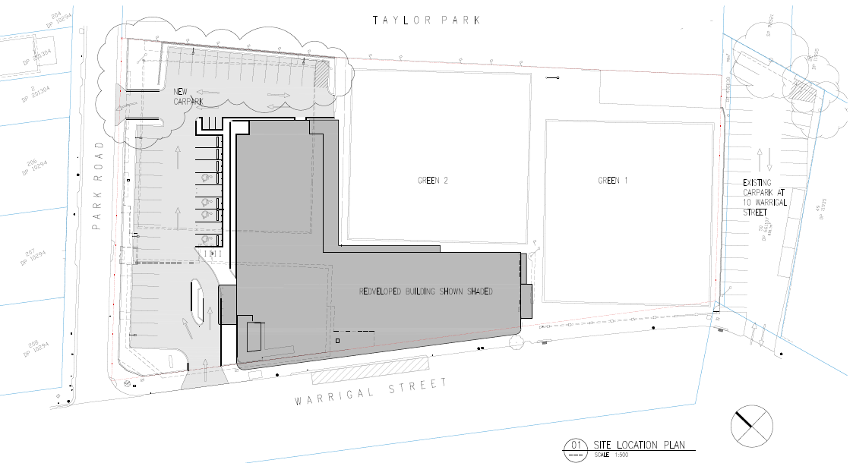

Above: Layout of the development

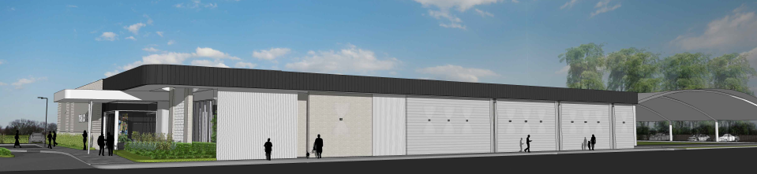

Above: Warrigal Street photomontage

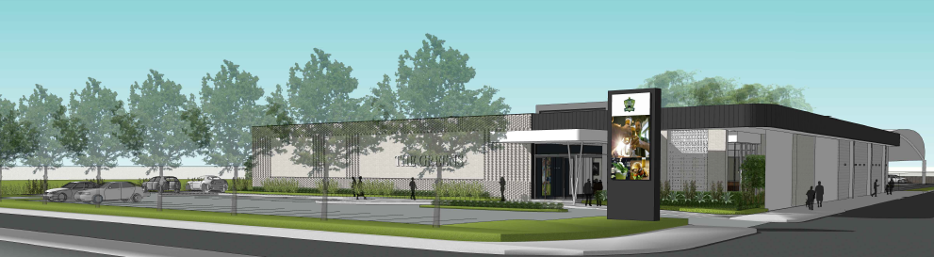

Above: View of development fromcorner of Park Road and Warrigal Street

* 1. **Background**

The development application was lodged on 3 September 2021. A chronology of the development application since lodgement is outlined in **Table 2**.

**Table 2: Chronology of the DA**

|  |  |
| --- | --- |
| **Date** | **Event** |
| 3 September 2021 | DA lodged |
| 15 September 2021 | Exhibition of the application |
| 15 September 2021 | DA referred to external agencies |
| 22 November 2021 | Request for Information from Council to applicant |
| 13 October 2021 | Panel kick off briefing |
| 8 December 2021 | Panel briefing |
| 31 January 2022 | Amended plans and information lodged |
| 1 June 2022 | Further Panel Briefing |
| 30 June 2022 | Applicant submitted copy of plans (submitted to Land Registry Services) |
| 20 July 2022 | Panel Determination Meeting |

* 1. **Site History**

The subject site contains a Registered Club, three bowling greens, a sporting oval, amenities block and car parking. The existing club building is part single storey/part two storey.

The site is owned by Central Coast Council and is covered by a Plan of Management.

The Plan of Management (No.6 – Taylor and Shore Parks The Entrance) states:

*Bowling Club*

*The Entrance Bowling Club was formed in 1939, when a site was selected at The*

*Entrance Oval, now known as Taylor Park. Taylor Park was dedicated for public*

*recreation by the subdividers of the Taylor Estate, Mrs H Denning, Austin Taylor and*

*Councillor A L Taylor in 1929. The newly formed Bowling Club duly approached the*

*subdividers and were granted a section of the area for the establishment of a Club.*

*After the first Taylor subdivision, the sportsground had been handed over to the old*

*Erina Shire Council and in due course, with the subdividers consent, a section of the*

*oval was allocated by plain lease to The Entrance Bowling Club.*

*Lots to the west of Taylor Park were purchased by The Entrance Bowling Club prior to*

*1960. A further two lots were acquired prior to 1963 and another lot was purchased in*

*1967. Council granted a lease in 1960 for a period of 21 years. The Entrance Ladies Bowling Club and The Entrance Bowling Club Ltd consolidated in 1981, operating under one lease. An application was approved in 1995 for extensions to The Entrance Bowling Club. The proposal includes the relocation of one of the bowling greens partly over the area of Taylor Park (Council File No: D/007144).*

In March 2020, a significant fire within the two-storey section of the club building caused fire, water, and soot damage to the entire building and forced the club to cease trading. Building investigations have determined that the Club requires significant remediation to return the building to a state that allows for occupation and recommencement of trade.

* Development Consent No. DA/183/2021 was granted for the site on 22 March 2021 for Use and Fitout as Food & Drink Premises (Greens Bowling Club). The proposal was for the change of use of a portion of the existing greenkeepers shed to a food and drink premises to provide food and drink to members of the bowling club in the interim until the club is rebuilt.
* Development Consent No. DA/1262/2020 was granted for the site on 20 January 2021 for demolition of a portion of the Registered Club affected by fire damage.

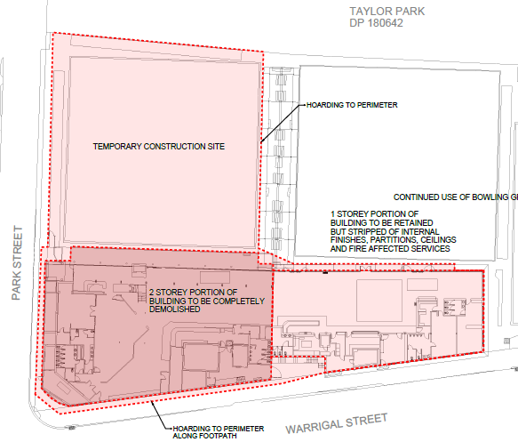

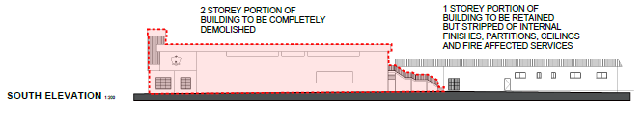

* Development Consent No. DA/1257/2007 was granted on 22 October 2007 for alterations and additions to The Entrance Bowling Club (now known as The Greens).
* A prelim-meeting (PL/251/2020) was held in relation to the current proposal on 4th November 2020.
* Previous Development Consent granted for extensions and upgrading of the bowling club for the site dating back to 1973 have required provision of 152 parking spaces with 116 spaces located on the lots known as Lots 53, 54 and 55 Taylor Street (now known as part of 21 Park Road) and 36 spaces on the adjoining bowling club land known as Lot 208 Warrigal Street (which is on the corner of Warrigal Street and Park Road). The parking approved for Lot 208 has never been constructed (as it would have required the demolition of the existing buildings/structures) and instead it was conditioned that a legal agreement was required that the parking spaces be constructed at a future point in time should Council deem them necessary.
* DA No.74/(105) consent granted for additions and alterations to existing Bowling Club House dated 31 May 1974
* Development Consent No. 274/77 dated 23 Sept 1977 was granted for use of Lot 50 DP.11935 for a car parking area (31 spaces). Part Lot 50 Warrigal Street adjoins the eastern side of the bowling club and it is noted. However, the parking was not formally constructed.
* DA No.551/1992 – Additions to clubhouse granted 20 Oct 1992. This consent was for extensions to the bowling club and the erection of an ancillary shed and required the provision of a further 15 spaces that were also to be deferred. It was noted that the existing parking on Lots 53, 54 and 55 Taylor Street was under-utilised in favour of closer on street parking and that *Council will need to consider the provision of better car parking*.
* DA No.1341/94 for alterations and additions to the existing club granted on 20 March 1995 and required the provision of 45 parking spaces.
* The consents granted above do not appear to reference operating hours for the club. The club currently trades on the following hours:

Monday to Saturday – 9.00am to 12.30am.

Sunday – 9.00am to 11.00pm.

* Council has resolved to reclassify and sell the land upon which the current club lease sits. However, to date the land remains community land and the land is part of the larger lot containing Taylor Park. The Minutes of Council’s Ordinary Meeting of 27 July 2021 containing the Resolution for the sale of the land under Item 2.1, Section 11 are below:

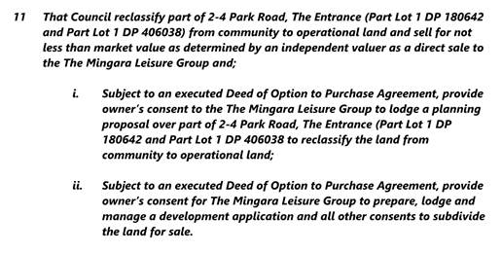

1. **STATUTORY CONSIDERATIONS**

When determining a development application, the consent authority must take into consideration the matters outlined in Section 4.15(1) of the *Environmental Planning and Assessment Act 1979* (‘EP&A Act’). These matters as are of relevance to the development application include the following:

1. *the provisions of any environmental planning instrument, proposed instrument, development control plan, planning agreement and the regulations*
2. *the likely impacts of that development, including environmental impacts on both the natural and built environments, and social and economic impacts in the locality,*
3. *the suitability of the site for the development,*
4. *any submissions made in accordance with this Act or the regulations,*
5. *the public interest.*

These matters are further considered below.

It is noted that the proposal is not considered to be:

* Integrated Development (s4.46)
* Designated Development (s4.10)
* Requiring concurrence/referral (s4.13)
* Crown DA (s4.33)
  1. **Section 4.15(1)(a)(i) - Provisions of Environmental Planning Instruments**

The following Environmental Planning Instruments are relevant to this application:

* *State Environmental Planning Policy (Resilience and Hazards) 2021*
* *State Environmental Planning Policy (Industry and Employment) 2021*
* *State Environmental Planning Policy (Planning Systems) 2021*
* *Wyong Local Environmental Plan 2013*

A summary of the key matters for consideration arising from these State Environmental Planning Policies are outlined in **Table 3** and considered in more detail below.

**Table 3: Summary of Key Matters in the Relevant Planning Controls**

|  |  |  |
| --- | --- | --- |
| **EPI** | **Matters for Consideration** | **Comply (Y/N)** |
| SEPP (Planning Systems) 2021. | * Clause 2.19 declares the proposal as regionally significant development pursuant to Clause 3(b) Schedule 6 of the SEPP (Planning Systems) 2021. | Y |
| SEPP (Resilience and Hazards) | * Chapter 3 (Remediation of Land) - Potential contamination and remediation has been considered in the assessment of the proposal. The site has no history of known contamination and the current club use dating back to 1939 is continuing on the site. * Chapter 2 (Coastal Management) - The site is located within both the Coastal Use Area and Coastal Environment Area, however the bowling club leased area is only located partially within the Coastal Environment Area. The proposal is consistent with Section 2.10 and 2.11 of the SEPP. | Y |
| SEPP (Industry and Employment) 2021 | * Chapter 3 (Advertising and Signage) - Concern is raised in relation to the potential visual and amenity impacts of the proposed plinth signage given its size and illumination in a residential area. | Y  (subject to conditions) |
| Draft EPIs | Draft SEPP (Remediation) 2018. No compliance issues identified in any Draft SEPP’s. | Y |
| WLEP 2013 | The main part of the site is not mapped with a height control under Clause 4.3 although all the surrounding land has a height limit of 12m. 10 Warrigal St has an LEP height limit of 12m.  Under Clause 4.4, the maximum FSR for the site is 3:1. The proposal has an FSR of 0.23:1 (the former club had an FSR of 0.35:1)  Clause 5.21 - The larger site containing the field is identified as flood affected but the part of the site where the club building is to be located is not identified as flood prone of a flood planning area.  Clause 7.1- The site mapped as potentially containing Class 5 acid sulfate soils (ASS). Only minor excavations are proposed, however, a geotechnical report has been prepared which included soil sampling which was not indicative of actual acid sulphate soils. The report concluded that an ASS management plan is not required  Clause 7.9 – The development has satisfactory access to reticulated services. | Y |
| CCLEP 2022 | The savings provisions apply to this DA which was lodged prior to the commencement of CCLEP. Under CCLEP 2022, the site retains its RE1 Public Recreation zoning and Registered Club remains permissible. | Y |
| WDCP 2013 | - Chapter 2.11 – Parking and Access.  The proposal has a significant shortfall in parking provision.  - Chapter 2.6 – Signage  - Chapter 3.1 – Site Waste Management  - Chapter 5.3 – The Entrance Peninsula | Y  (subject to conditions) |
| CCDCP 2022 | The application predates the operation of CCDCP 2022 and therefore Wyong DCP 2013 applies. There is no significant change in relevant DCP controls for parking or other matters under CCDCP 2022. | Y |

*State Environmental Planning Policy* (Planning Systems) 2021

*State Environmental Planning Policy* (Planning Systems) 2021 applies to the proposal as it identifies if development is regionally significant development. In this case, pursuant to Clause 2.19, the proposal is a regionally significant development as it satisfies the criteria in Clause 3(b) Schedule 6 of the SEPP (Planning Systems) 2021 as the proposal is development for Council related development with a CIV over $5 million.Accordingly, the Hunter and Central Coast Regional Planning Panel is the consent authority for the application. The proposal is consistent with this Policy.

State Environmental Planning Policy (Resilience and Hazards) 2021

*Chapter 4 – Remediation of Land*

The provisions of *State Environmental Planning Policy (*Resilience and Hazards) 2021 (‘SEPP RH’) Chapter 3 (Remediation of Land) have been considered in the assessment of the development application.

Section 4.6 of SEPP RH requires consent authorities to consider whether the land is contaminated, and if the land is contaminated, it is satisfied that the land is suitable in its contaminated state (or will be suitable, after remediation) for the purpose for which the development is proposed to be carried out.

The site has a history of use for recreation purposes including as a bowling club dating back to 1939. The application does not involve any change of use under subsection (2) on any land specified in subsection (4). The demolition works for the fire damaged club have been carried out under a separate consent. The land is considered suitable for the development proposed to be carried out and the proposal is consistent with the provisions of the SEPP in this respect.

*Chapter 2 – Coastal Management*

The provisions of *State Environmental Planning Policy (*Resilience and Hazards) 2021 (‘SEPP RH’) Chapter 2 (Coastal Management) have been considered in the assessment of the development application.

The site is located within both the Coastal Environment Area and the Coastal Use Area, although the club leased area is confined to within the coastal environment area

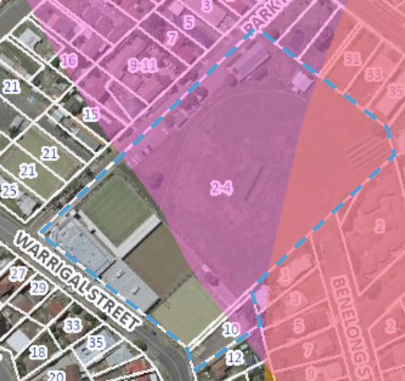 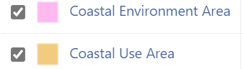

Above: Aerial view of site showing coastal mapping

Under the development controls that apply to the coastal environment area under Section 2.10, development consent must not be granted unless the consent authority has considered whether the proposed development is likely to cause an adverse impact on the matters identified under subsection (1)(a)-(g). The proposal is considered satisfactory with regard to these matters and in accordance with subsection (2) *the development is designed, sited and will be managed to avoid an adverse impact referred to in subsection (1).* In this regard, the site is located within an established urban environment and has no direct and physical interface with the coast and is not readily visible from the foreshore.

Under the development controls that apply to the coastal use area under section 2.11, development consent must not be granted to development on land that is within the coastal use area unless the consent authority has considered whether the proposed development is likely to cause an adverse impact on matters (i)-(v) and is satisfied the development is designed, sited and will be managed to avoid any such adverse impact. The site is located away from any direct interface with the foreshore area or any nearby coastal headland. The site is located within an established urban area and will not impact on any aboriginal, cultural or built heritage. Additionally, in accordance with subsection (c), the surrounding coastal and built environment, and the bulk, scale and size of the proposed development has been taken into account in the assessment of the proposal under this section.

State Environmental Planning Policy (Industry and Employment) 2021

*Chapter 3 – Advertising and Signage*

The provisions of Chapter 3 (Advertising and Signage) SEPP (Industry and Employment) 2021 (SEPP IE) apply to the proposal. The proposed development seeks approval for new identification signage associated with the business including a wall sign and a pylon/plinth sign as follows:

- A 5.9m high, plinth Sign with a doubled sided LED screen (4m x 2.05m)

- A wall sign displaying the words “The Greens” 7m long x 0.7m high

Under the SEPP IE, the signage would be considered as ‘business identification signs’ and as such, Part 3.3 of the SEPP does not apply to the development. Business identification signage is defined under the standard instrument as:

‘business identification sign’ means a sign:

(a) that indicates:

(i) the name of the person, and

(ii) the business carried on by the person,

at the premises or place at which the sign is displayed, and

(b) that may include the address of the premises or place and a logo or other symbol that identifies the business,

but that does not include any advertising relating to a person who does not carry on business at the premises or place.

In accordance with Section 3.6 of the SEPP, the proposed signage:

- needs to be consistent with the objectives of the policy (under Section 3.1(1)(a)) and

- needs to satisfy the assessment criteria specified under Schedule 5 (Assessment criteria) of the instrument.

|  |  |
| --- | --- |
| Clause 3.1(1)(a)  This Chapter aims to ensure that signage (including advertising)- | Proposal |
| (i) is compatible with the desired amenity and visual character of an area, and | Concern was raised regarding the size and illumination of the plinth sign given the residential context of the area surrounding the site. The applicant provided additional information relating to light spill and management of the operation of the sign. |
| (ii) provides effective communication in suitable locations, and | Satisfactory |
| (iii) is of high quality design and finish | Satisfactory |
| Schedule 5 – Assessment Criteria |  |
| **1 Character of the area**  • Is the proposal compatible with the existing or desired future character of the area or locality in which it is proposed to be located?  • Is the proposal consistent with a particular theme for outdoor advertising in the area or locality? | Visual amenity and light glare impacts were raised as a concern due to the large size of the LED display area and the illumination of the plinth sign given the residential nature of the surrounding site context.  Its was requested the sign be reduced to a more human scale with a reduced LED display area which is more in keeping with the immediate site context and existing overall residential character of the area. |
| **2 Special areas**  • Does the proposal detract from the amenity or visual quality of any environmentally sensitive areas, heritage areas, natural or other conservation areas, open space areas, waterways, rural landscapes or residential areas? | The surrounding site context is residential and the proposed plinth signage has the potential to detract from the amenity and visual quality of the area. |
| **3 Views and vistas**  • Does the proposal obscure or compromise important views?  • Does the proposal dominate the skyline and reduce the quality of vistas?  • Does the proposal respect the viewing rights of other advertisers? | Satisfactory as there are no views or vistas impacted. |
| **4 Streetscape, setting or landscape**  • Is the scale, proportion and form of the proposal appropriate for the streetscape, setting or landscape?  • Does the proposal contribute to the visual interest of the streetscape, setting or landscape?  • Does the proposal reduce clutter by rationalising and simplifying existing advertising?  • Does the proposal screen unsightliness?  • Does the proposal protrude above buildings, structures or tree canopies in the area or locality?  • Does the proposal require ongoing vegetation management? | The scale of the plinth signage is excessive and unnecessary and out of character with the surrounding residential area. The size of the LED panels needs to be reduced to minimize the potential visual and amenity impacts. |
| **5 Site and building**  • Is the proposal compatible with the scale, proportion and other characteristics of the site or building, or both, on which the proposed signage is to be located?  • Does the proposal respect important features of the site or building, or both?  • Does the proposal show innovation and imagination in its relationship to the site or building, or both? | The plinth sign height is considered excessive against the scale and height of the proposed building. The height of the proposed signage is the same height as the building. |
| **6 Associated devices and logos with** **advertisements and advertising structures**  • Have any safety devices, platforms, lighting devices or logos been designed as an integral part of the signage or structure on which it is to be displayed? | N/A |
| **7 Illumination**  • Would illumination result in unacceptable glare?  • Would illumination affect safety for pedestrians, vehicles or aircraft?  • Would illumination detract from the amenity of any residence or other form of accommodation?  • Can the intensity of the illumination be adjusted, if necessary?  • Is the illumination subject to a curfew? | The plinth sign includes a large double sided LED display area of (4m x 2.05m each side) which will be readily visible from residential properties along the street.  The applicant has provided a report for the proposed LED sign against the relevant lighting standards and guidelines. |
| **8 Safety**  • Would the proposal reduce the safety for any public road?  • Would the proposal reduce the safety for pedestrians or bicyclists?  • Would the proposal reduce the safety for pedestrians, particularly children, by obscuring sightlines from public areas? | The plinth sign includes a large LEP display area with the potential for moving images to distract drivers. However, safety concerns have not been raised. |

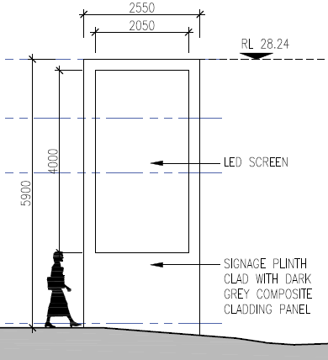 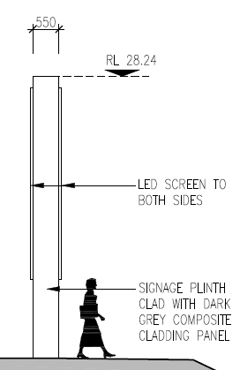 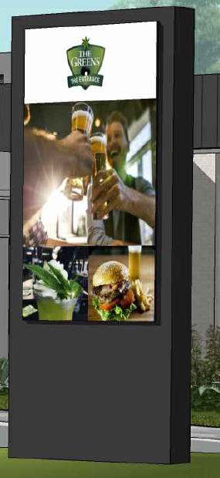

Above: Plans for the proposed LED signage plinth

In response to the concerns raised, the applicant has not changed the signage plans but has prepared a report assessing the proposed LED sign against the relevant lighting standards (AS/NZS 4282:2019; Control of the obtrusive effects of outdoor lighting) and against the guidelines (Transport Corridor Outdoor Advertising and Signage Guidelines under SEPP 64 – Nov 2017).

The applicant’s report identifies that the LED sign built in sensor adjusts the screen brightness between night and day and that the maximum brightness would only be used during the daytime when the sun is out. The report states: *The proposed LED advertising sign, automated in-built dimming capability shall be programmed such that the technical lighting parameters comply with the requirements of AS/NZS 4282:2019.*

The report concludes that: *The LED sign has the in-built capability to be programmed and automatically dimmed based on the ambient light levels to achieve compliance to SEPP 64. This programming will occur during commissioning and site luminance (brightness) readings shall be undertaken at the time of commissioning to confirm compliance*…*The proposed LED sign also has the capability to be monitored remotely through a secured network. The*

*brightness of the sign can be changed/adjusted remotely to cater for different environmental conditions and revert back to a pre-set compliant luminance/illuminance level should a sensor fail.*

There is no objection raised to the proposal wall signage. However, conditions are recommended to minimize the visual and amenity impacts of the proposed LEP plinth signage to better suit the site context. The recommended conditions include the plinth signage is to be reduced in scale by 33% (this includes a reduction to the LED display and the height) and the signage illumination is to be switched off outside of operating hours.

Subject to compliance with the aforementioned and other recommended conditions the signage is considered consistent with the objectives of the policy and satisfy the assessment criteria outlined under Schedule 5 of the instrument in accordance with Section 3.1(1)(a) of the SEPP. It is only on this basis that the signage is considered reasonable and compatible with the existing and future visual character of the area. The signage is not located within an environmentally sensitive area.

***Wyong Local Environmental Plan 2013***

*Zoning and Permissibility*

The site is located within the RE1 – Public Recreation pursuant to Clause 2.3 of the Wyong LEP 2013. The proposed development is defined as:

*Registered club means a club that holds a club licence under the Liquor Act 2007.*

The existing Bowling Greens No. 1 and 2 can be described as a recreational facility

(outdoor), which is defined as:

*Recreation facility (outdoor)*means a building or place (other than a recreation

area) used predominantly for outdoor recreation, whether or not operated for

the purposes of gain, including a golf course, golf driving range, mini-golf centre,

tennis court, paint-ball centre, **lawn bowling green**, outdoor swimming pool,

equestrian centre, skateboard ramp, go-kart track, rifle range, water-ski centre

or any other building or place of a like character used for outdoor recreation

(including any ancillary buildings), but does not include an entertainment facility

or a recreation facility (major).

A ‘registered club’ and ‘recreation facility (outdoor)’ are both permissible uses within

the RE1 Public Recreation Zone under the Wyong Local Environmental Plan 2013.

10 Warrigal Street is located within the R3 medium density residential zone and car parks permitted with consent. a car park is defined as:

*Car park* means a building or place primarily used for the purpose of parking motor vehicles, including any manoeuvring space and access thereto, whether operated for gain or not.

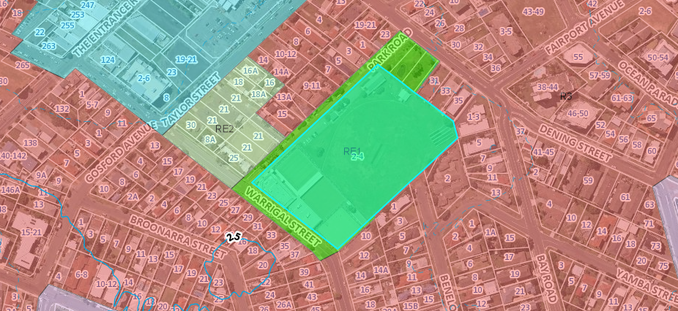

Above: Zoning map of the site and surrounds under WLEP 2013

*Zone objectives*

The RE1 and R3 zone objectives include the following (pursuant to the Land Use Table in Clause 2.3):

*Objectives of RE1 zone*

*•  To enable land to be used for public open space or recreational purposes.*

*•  To provide a range of recreational settings and activities and compatible land uses.*

*•  To protect and enhance the natural environment for recreational purposes.*

*•  To provide linked open space for ecosystem continuity, public access, local community recreation and waterway protection.*

*•  To provide space for integrated stormwater treatment devices for flow and water quality management.*

*•  To enable ancillary development that complements land zoned for recreational purposes.*

*Objectives of R3 zone*

*• To provide for the housing needs of the community within a medium density residential environment.*

*• To provide a variety of housing types within a medium density residential environment.*

*• To enable other land uses that provide facilities or services to meet the day to day needs of residents.*

*• To maintain and enhance the residential amenity of the surrounding area.*

*• To encourage amalgamation of existing lots to facilitate well designed medium density development and to avoid unnecessary isolation of lots.*

The proposal is considered to be consistent with these zone objectives for the following reasons:

* The land will continue to be used for a recreational purpose as a bowling club.

*General Controls and Development Standards (Part 2, 4, 5 and 6)*

The LEP also contains controls relating to development standards, miscellaneous provisions and local provisions. The controls relevant to the proposal are considered in **Table 4** below.

**Table 4: Consideration of the LEP Controls**

|  |  |  |  |
| --- | --- | --- | --- |
| **Control** | **Requirement** | **Proposal** | **Comply** |
| Height of buildings  (Cl 4.3(2)) | Site is not mapped with a height control under Clause 4.3 although all the surrounding land including 10 Warrigal St. has a height limit of 12m. | The new club building is 5.8m in height. The maximum height of the development is 8.83m (measured from existing ground level to top of the bowling green  cover). | No control applies |
| FSR  (Cl 4.4(2)) | Under Clause 4.4, the maximum FSR for the site is 3:1. | The proposal has an FSR of 0.23:1 (the former club had an FSR of 0.35:1) | Yes |
| Acid sulphate soils  (Cl 7.1) | Clause 7.1- The site mapped as potentially containing Class 5 acid sulfate soils (ASS). | Minor excavations are proposed, however, a geotechnical report has been prepared which included soil sampling which was not indicative of actual acid sulphate soils. The report concluded that an ASS management plan is not required | Yes |
| Flood planning (Cl 5.21) | Clause 5.21 – Consent not to be granted unless satisfactory with regard to flooding. The larger site containing the field and 10 Warrigal Street are both identified as flood affected. | The part of the site where the club building is to be located is not identified as flood prone or a flood planning area. The parking at 10 Warrigal will experience flooding with a depth less than 100mm. | Yes |
| Essential Services  (Cl.7.9) | Clause 7.9 – Consent must no be granted unless essential services available or adequate arrangements made for their availability | The site located within an area that is serviced. All services are available and will be provided to the proposed development | Yes |

The proposal is considered to be generally consistent with the LEP.

**Central Coast Local Environmental Plan 2022**

Central Coast Local Environmental Plan 2022 (CCLEP) was published 24 June 2022 and is due to commence on 1 August 2022 and has been considered in the assessment of the application. CCLEP 2022 contains a savings and transitional provision that provides at clause 1.8A:

*‘If a development application has been made before the commencement of this Plan*

*in relation to land to which this Plan applies and the application has not been finally*

*determined before that commencement, the application must be determined as if this*

*Plan had not commenced.’*

There is no change to the zoning of the site or significant change to other relevant statutory matters as they apply to the proposal under the CCLEP, that require specific discussion in relation to the proposal.

* 1. **Section 4.15 (1)(a)(ii) - Provisions of any Proposed Instruments**

There are several proposed instruments which have been the subject of public consultation under the EP&A Act, and which may be relevant to the proposal, including the following:

* *Draft Remediation of Land SEPP*
* *Draft Design and Place SEPP*

*Draft Remediation of Land SEPP*

The key operational framework of the former SEPP 55 is maintained in the new SEPP which will still require consent authorities to consider whether the site is, or is likely to be, contaminated, and permit a consent authority to require additional information to satisfy itself as to whether the land is contaminated.

Having regard for the Explanation of Intended Effect, and the site history of use as a recreational area and registered club, the proposed development is considered satisfactory with regard to the draft SEPP.

*Draft Design and Place SEPP*

In her recent instructions to local government, the Secretary emphasised that, for the purposes of section 4.15(1)(a)(ii) of the Environmental Planning and Assessment Act 1979, the draft proposed Design and Place SEPP 2021 is not notified to any consent authorities and is therefore not a mandatory matter for consideration under the Act. The Draft SEPP is not to be applied to the assessment of development applications until the policy is finalised.

* 1. **Section 4.15(1)(a)(iii) - Provisions of any Development Control Plan**

The following Development Control Plan is relevant to this application:

* *Wyong Development Control Plan 2013* (‘the DCP’)

*- Chapter 1.2 - Notification of Development Proposals*

*- Chapter 2.6 – Signage*

*- Chapter 2.11 - Parking and Access*

*- Chapter 3.1 - Site Waste Management*

- *Chapter 5.3 – The Entrance Peninsula*

*DCP Chapter 2.11 – Parking and Access*.

The proposal has a shortfall in parking provision under Wyong DCP Chapter 2.11. The DCP requires parking for the development to be on the basis of the table below.



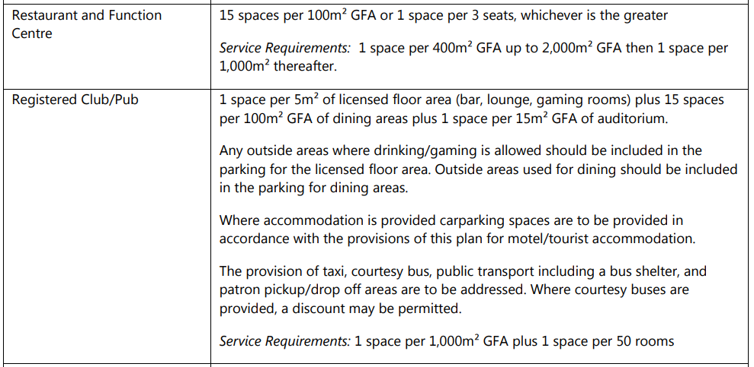

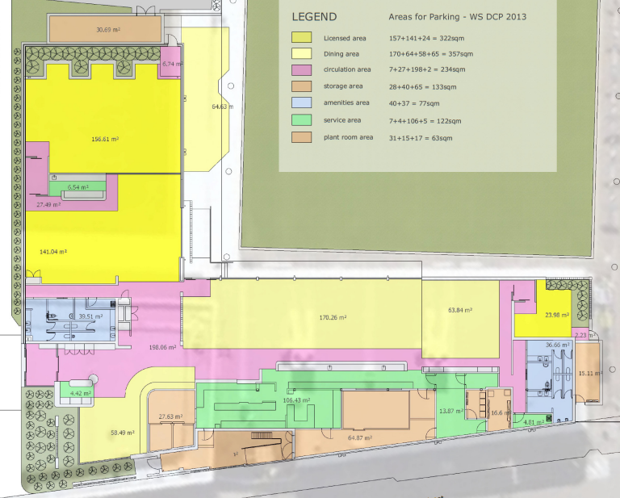

Above: The areas shown in yellow above are the GFA used in the calculation for parking

The proposal includes:

2 bowling greens (45 spaces) plus

Dining areas - 357m² GFA (53.55 spaces) and

Licenced areas - 322m² GFA (64.4 spaces).

Based on the above DCP requirements, the proposal generates parking demand of 163 spaces. However, the applicant has argued in the traffic report that the bowling greens are *ancillary to the club* use and *all bowlers will use the club facilities* and so on this basis the 45 spaces required for the bowling greens are to be deducted from the total demand of 163 spaces leaving the total parking demand for the proposal being solely based on the club dining and licenced areas generating a parking demand for 118 spaces plus 1 service bay.

The traffic report for the proposal also identifies a requirement for 3 accessible spaces, 3 motorbike spaces and 13 bicycle parking spaces.

The proposal includes construction of 37 car spaces on the site and the use of (up to) 30 spaces on the adjoining site at 10 Warrigal Street. This totals parking for up to 67 vehicles but there remains a shortfall of 51 spaces (accepting the applicant’s arguments about the bowling greens) or a shortfall of 96 spaces if this argument is not accepted. The proposal also includes a designated drop off/pick up area at the club entry.

The DCP identifies that where *courtesy buses are provided, a discount maybe permitted*.

However, the applicant has advised there will not be any courtesy bus provided with the proposal.

The consent history of the club includes the approved use of the existing parking (not only at 10 Warrigal Street but) at Lots 53, 54 and 55 in DP 10294 and Lot 1 DP 201304 known as 21 Park Road. Parking also had been previously approved at Lot 208 (25 Park Road) for club extensions but parking provision was deferred and appears to have never been constructed.

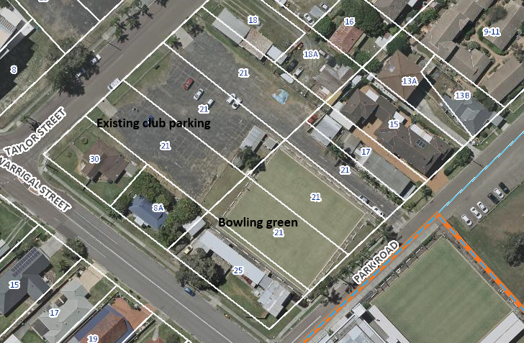

Ordinarily the altering or rebuilding of a development cl3.12 of chapter 2.11 of the DCP requires parking to be provided for in accordance with the rates specified in the plan however, where the use is in essence a status quo no additional parking is required. The parking for the proposal does not include the retention and use of the approved historic parking spaces existing on these surrounding lot as being associated with the club and therefore the proposal is not a status quo, but rather seeks a substantial variation to the required parking provision required under the DCP..

In response to the concerns raised regarding the shortfall and the use of the existing approved parking to address this concern, the applicant has provided the following:

*The above lots commonly known as No. 21 and No. 25 Park Road are not included in this proposed development. Based on previous history to car parking, Council in the past had the ability to enforce additional parking associated with the bowling club’s use and deferred the matter. It is assumed there is no requirement to include the existing car parking spaces on these lots and connect them with the subject site’s existing use. These lots are also identified in the LEP’s Additional Permitted Uses Map for future development for the purposes of hotel or motel accommodation, residential care facilities, seniors housing and serviced apartments if associated with a registered club. These lots are not owned by Council and are also not included within the subject sites Lease Arrangements with Council for 2-4 Park Road.*

*The carpark at No. 2-4 Park Road has been amended as discussed above and as a result, this has reduced the number of carparking spaces from 38 to 37. The proposed number of car parking spaces for the redeveloped club is now 67 which includes the existing parking at No. 10 Warrigal Street. The DCP considers the option of providing a courtesy bus service to discount car parking for a registered club.*

*The DCP states:*

*The provision of taxi, courtesy bus, public transport including a bus shelter, and patron pickup/drop off areas are to be addressed. Where courtesy buses are provided, a discount may be permitted.*

*The applicant, Mingara Leisure Group have considered a courtesy bus service, however, as this service is not feasible for the Club, it will not be provided. The Mingara Club at Tumbi Umbi which is a larger Club, does not provide a courtesy bus service anymore due to the same reasons for the service not being feasible. Since Uber commenced on the Central Coast and post-covid lock down periods, the return of patrons to Mingara owned Clubs are relying on Uber service, Taxi’s, public transport, car pooling or walking to the Club. Club operations can confirm that patrons prefer to call an Uber or a Taxi instead of waiting 1 hour for a courtesy bus.*

*The car parking deficiency can be off-set against the use of the existing 22 car spaces for the Sports Fields north of the site (which is part of No. 2-4 Park Road) during peak trading times, including patrons who walk or catch public transport, taxi or Uber to the Club. This is further discussed and justified in the Traffic and Parking Assessment Report prepared by Intersect Traffic submitted with the DA. Noting the Club’s history to carparking and that Council in the past has allowed a parking shortfall, the proposed development represents a significant improvement. The redeveloped Club has a reduced floor area (FSR 0.23:1) to the existing Club building (FSR 0.35:1), and now provides additional car parking on the site which is far better than the current situation.*

*The location of the site is also in walking distance to The Entrance Town Centre and there is public transport, taxi and uber services available to assist in catering for the shortfall in car parking which has also been identified in the Traffic and Parking Assessment Report and has addressed the requirements of the DCP. In addition to the above, the Traffic Consultant has provided additional information in a letter dated 5 December 2021 (see Attachment 7). Parking surveys undertaken by Intersect Traffic at a number of clubs in the Newcastle and Port Stephens Council areas has shown recreational clubs tend to generate an actual parking demand well less than the DCP parking requirements. This is because the parking rates adopted in the local DCP’s are based on 40 year old traffic surveys undertaken by TfNSW in the late 1970’s and early 1980’s. Trip making habits of patrons of these type of clubs since these surveys have changed due to legislation (drink driving laws) and community expectations (drink driving education) and many more patrons are using alternate transport modes (walking, ride share, uber, taxi etc) to attend the club. Patrons are putting more time and effort into planning their trip making decisions to attend the club. This has resulted in significantly lower actual peak parking demand rates at registered club developments when compared to DCP parking rates and for this reason it is considered that lower than DCP parking supply can be justified for the proposed development.*

*It is requested Council consider the proposed car parking and its variation to the DCP which has been adequately addressed above; in the Statement of Environmental Effects and in the Traffic and Parking Assessment Report prepared by Intersect Traffic. An amended traffic report which includes the acoustic wall at the north end of the carpark is within Attachment 7A.*

The applicant’s traffic report has noted the following arguments in favour of supporting the shortfall:

* Availability of nearby on-street parking. A desktop survey of the utilisation of on and off-street car parking spaces in the area was undertaken (between April 2021 and Dec 2019) and revealed:

*- In total the number of available spaces on these roads is approximately 200*

*- The minimum available on-street parking spaces on any of these occasions between was 138*

it demonstrates ample availability of parking within close and reasonable walking distance of the site,

* The existence of the 22 off-street car spaces adjacent to the sports field in Park Road adjoining the northern side of the development during peak trading periods.
* The variety of alternative transport modes, other than car transport, available for staff and visitors of the site. The use of public transport, buses, the abundance of bicycle, footpath and shared pathway access for site access which can be utilised by staff, local residents, visitors staying at nearby accommodation or travelling from home; and private hired transport including taxis, ubers and other shared transport.
* There is a historic deficiency of parking for 45 spaces associated with the club wherein Council had approved the parking but deferred its construction on the basis that if formally requested by Council, the determined shortfall would be provided. Council has not required the club to provide this car parking for over 25 years.
* Staff and visitors using the development space are encouraged to utilise these public transport services to reduce the travel demand on the public road network and the inclination to drink and drive.

To further support this the applicants Traffic consultant has noted:

*Further parking surveys undertaken by Intersect Traffic at a number of clubs in the Newcastle and Port Stephens Council areas has shown these recreational clubs tend to generate an actual parking demand well less than the DCP parking requirements. This is because the parking rates adopted in the local DCP’s are based on 40 year old traffic surveys undertaken by TfNSW in the late 1970’s and early 1980’s. Trip making habits of patrons of these type of clubs since these surveys have changed due to legislation (drink driving laws) and community expectations (drink driving education) and many more patrons are using alternate transport modes (walking, ride share etc) to attend the club. Patrons are putting more time and effort into planning their trip making decisions to attend the club. This has resulted in significantly lower actual peak parking demand rates at these types of developments when compared to DCP parking rates and for this reason it is considered that lower than DCP parking supply can be justified for this type of development.*

Whilst the arguments that the applicant has provided for excluding some of the parking demand (of 45 spaces) generated by the bowling greens (ie. on the basis that the use of the bowling greens is in conjunction with the use of the club and the historic shortfall associated with the club) would appear reasonable; the argument provided to exclude any calculation of DCP parking demand for the bowling greens altogether does not appear to be fully reasoned. Additionally, the arguments also seeking to justify a further reduction in parking demand for the club operations by 51 spaces does not appear warranted in this instance and is not supported.

It is not reasonable or consistent with the DCP to rely on street parking or public parking associated with sports ground to cater for the development. Street parking may be relied upon for occasional demands such as special functions or the like but reliance on street parking to meet the DCP requirements removes the buffer for large events, gives rise to amenity impacts and as the R3 land is developed for more intensive housing reduces what is likely to be in demand as visitor parking.

Although it is acknowledged that a number of these arguments appear to be reasonable to support a ‘minor’ shortfall in parking associated with a club operating on the site, the extent of shortfall proposed in this instance (which is compounded by no consideration of the bowling greens parking demand for 45 spaces) is considered too significant to reasonably support.

Therefore, to address the parking shortfall and create a reasonable basis for approval, that being a parking status quo a condition will be recommended that the existing approved club parking located at Lots 53, 54 & 55 in DP 10294 at 21 Park Road is to be retained and used as part of this new club operations.

*DCP Chapter 3.1 - Site Waste Management*

In accordance with DCP Chapter 3.1, the applicant submitted a Waste Management Plan for the development outlining the waste disposal, re-use and recycling (on and off site) for the construction and operational stages of the development. A recommended condition has been included requiring the development to be carried out in accordance with the submitted management plan.

*DCP Chapter 2.6 – Signage*

The application seeks approval for signage including:

* A 5.9m high, plinth Sign with a Doubled sided LED screen (4m x 2.05m)
* A wall sign displaying the words “The Greens” 7m long x 0.7m high

Both will contain the name of the business occupying the site and therefore the signage relates to the land on which it is located. The plinth signage will also contain a double sided LED display which subject to recommended conditions to minimise its overall scale and impacts will be acceptable.

Although the proposed signage type is typical of the nature and type of signage associated with registered clubs, its scale is not compatible with the immediate site context. Subject to recommended conditions (as discussed earlier in the report) to ensure it better fits in with the site context, the signage will better align with the DCP objectives under Clause 1.1 as follows:

* *To encourage high quality signage that is properly designed, located and maintained*
* *To allow for the provision of signage that is compatible with the desired amenity and visual character of an area*
* *To provide for the effective communication of information in suitable locations*

The proposal is not a type of signage identified under Clause 3 as not being permitted.

DCP *Chapter 5.3 – The Entrance Peninsula*

The proposal is generally consistent with the relevant aims and requirements of DCP Chapter 5.3 to provide an attractive streetscape which reinforce the function of a street and enhance the amenity of dwellings. The site is not specifically included within a mapped precinct area under the DCP. The proposal is not excessively bulky and will activate the Park Road street frontage with landscaping and the building entry oriented to this frontage. Although the architecture and landscape setting is not specifically coastal in character, the proposal does include outdoor dining areas and provides for outdoor recreational activities which take advantage of the coastal climate. The redevelopment of the site will provide some positive activation of the street and enhancement of the area.

Contributions

The following contributions plans are relevant pursuant to Section 7.18 of the EP&A Act and have been considered in the recommended conditions (notwithstanding Contributions plans are not DCPs they are required to be considered):

* *Central Coast Regional Section 7.12 Development Contributions Plan 2019*

The S7.12 Contributions Plan has been considered and the required contribution under the plan has been calculated based on the latest revised CIV for the development and the contribution will be included any recommended draft consent conditions.

* 1. **Section 4.15(1)(a)(iiia) – Planning agreements under Section 7.4 of the EP&A Act**

There have been no planning agreements entered into and there are no draft planning agreements being proposed for the site.

* 1. **Section 4.15(1)(a)(iv) - Provisions of Regulations**

Clause 92(1) of the Regulation contains matters that must be taken into consideration by a consent authority in determining a development application. These provisions have been considered and addressed in the draft conditions (where necessary).

* 1. **Section 4.15(1)(b) - Likely Impacts of Development**

The likely impacts of that development, including environmental impacts on both the natural and built environments, and social and economic impacts in the locality must be considered. In this regard, potential impacts related to the proposal have been considered in response to SEPPs, LEP and DCP controls outlined above and the Key Issues section below.

The consideration of impacts on the natural and built environments includes the following:

* *Access and parking design*

The road fronting the Bowling Club is generally in good condition with kerb and gutter and footpaving (full width in front of the club buildings in Warrigal Street). With the majority of the club buildings burnt down, the development is proposing to construct a new carparking area on the corner of park Rd and Warrigal Street with main access to the club from this carpark. The entry to the carpark shall be from Warrigal Street with one way traffic movement to the exit in Park Road. A short 2-way parking lane will be available at the northern side of the parking area. There will also be parking linked to the property at 10 Warrigal Street which will need to be formalised to serve the club with a 2-way entry and exit.

The existing internal carparking be required to comply with AS/NZS2890.1 with one way traffic movement and 2-way movement at the northern end. Suitable signage and pavement marking will be required and drop off area at the front entry. The carparking area at 10 Warrigal Street is currently in separate ownership to the site but is proposed to be linked to the development via a caveat (or similar). The car park at 10 Warrigal Street will need to be formalised with suitable pavement surfacing and signage and line marking under recommended conditions.

Similarly, the existing approved parking Lots 53, 54 and 55 at 21 Park Road will need to be clearly line marked for continued use by the new club. A caveat or easement or equivalent will also be needed over the existing approved parking on these lots. The purpose of the caveat or easement is to ensure the above land is used for car parking for the patrons, visitors and staff of the redeveloped club located at 2-4 Park Road. The caveat or easement on 10 Warrigal Street can be removed when 10 Warrigal Street is consolidated on the same lot as the club. The caveat or easement for Lots 53, 54 and 55 at 21 Park Road is to remain until an alternative arrangement can be made to provide for shortfall in parking spaces needed to service the redeveloped club.

The development is proposing to retain an existing loading dock area that utilises the Council footway area and an indented area of the development site for deliveries and waste. Council will require a detailed management plan for the loading zone area to ensure the safety of pedestrian and vehicles when the area is in use. This will be included under the recommended conditions and will need to be certified by a suitably qualified traffic / safety engineer and approved by the registered certifier.

The construction of the main carparking area shall include suitable pavement and edge surrounds, wheel stops on all spaces, asphalt surface and line marking and signage. The submitted plans are considered suitable and requirements will be included under the recommended conditions. Stormwater for the car park is proposed to connect to the existing drainage on the site. The carpark at 10 Warrigal St will need to formalised. The applicant will need to ensure that the carparking area remains compliant with AS/NZS 2890.1 and the pedestrian desire lines and safety are considered.

* *Stormwater Management*

Runoff collected from hardstand areas will be directed via a pit and pipe system to a below ground onsite detention (OSD) tank located below the carpark pavement. Overflows from the OSD tank will be conveyed to the existing stormwater pipe to the north of the site. Runoff from roof areas will be collected and directed to the existing stormwater pipe on Warrigal Street and to the existing bore water tank below the Greens Keepers Shed which is to be converted to an OSD tank. Overflow from this OSD tank will be directed to the existing stormwater pit and pipe located to the north of the site.

There is a Council drainage line that runs through the carparking area adjacent to No 10 Warrigal Street on a separate lot known as Lot 1 DP406038. Stormwater will be directed to this drainage system with the OSD system included to ensure flows do not impact on the capacity of the system.

* *Flooding*

The proposed development areas are generally above the 1% AEP flood event though the property at 10 Warrigal St proposed to be utilised for carparking is affected by flooding to a depth of generally less than 100mm with it mostly below 50mm. This is not considered significant.

* *Earthworks*

Earthworks are expected to be limited to the proposed pavement for the carparking area and building development. Acid sulphate soils (ASS) are class 5 and a review of the data set risk mapping for ASS for Councils Local Environmental Plan 2013 indicates that it is in a zone of “no known occurrences”. This is supported by the assessment undertaken by RCA Australia that the proposal will not be impacted by ASS.

* Easements, 88B Requirements, etc

There are a number of encroachment issues with the development. There is road widening within the property which has not been formalised. There are encroachments within the road reserve and within No10 Warrigal St. A proposal to include a caveat or similar to link the carparking at No10 Warrigal St to the development will be problematic if the subject development site is subdivided off and required to be consolidated. This may all need to be included in a deferred commencement condition.

* *Air Quality*

It is anticipated that this proposal will not significantly impact the surrounding environment. During the construction phase for this proposal it is anticipated that there maybe short term impacts, but these can be controlled with a conditional requirement for any development consent issued.

* *Light intrusiveness impacts*

Consideration has been given to the documentation provided and whether the use and management of lighting for this proposal can be undertaken in a manner that does not unreasonably impact upon the surrounding amenity of the neighbourhood.

Although the visual impact assessment prepared by the applicant has determined that it complies with AS/NZS 4282:2019, concern remains that the size of the sign which is surrounded by residential properties and the use of strobe lighting may have the potential of causing sleep disturbance and amenity issues within the liveable sections of the dwelling, eg. during the early hours of the morning. These concerns, although not restrictive to the progression of the development application are to be managed with specific conditions for any development consent issued.

* *Noise*

The applicant prepared an amended acoustic report which assessed the operational noise from patron usage of the proposed gaming, dining and bar areas against Liquor & Gaming NSW noise criteria, as well as noise impacts based on the NSW EPA Noise Policy for Industry noise criteria. The use of the car parking at both 10 Warrigal Street and the western car park have been assessed in the applicant’s report.

Consideration has been given to the acoustic reports prepared on behalf of the applicant by Council’s Senior Environmental Protection Officer. The sampling data, methodology and findings of this acoustic assessment have been reviewed the recommendations and noise control measures specified in the acoustic report are supported. It is noted that the outdoor function area may have a potential of causing offensive noise, but with the added attenuation measures of the plant room, distance and acoustic fence at the boundary it is anticipated that any elevated noise can be managed by the club or will be regulated by the Tuggerah Lakes Police District.

The acoustic report includes a number of recommendations including:

* Management procedures to ensure patrons are well behaved and speech noise levels are not unreasonably elevated.

- Signage should be displayed to ask patrons to keep their noise level to a minimum in the late evening hours, out of respect and consideration to the nearby neighbouring residential premises.

- The venue operation will be conducted in accordance with the Responsible Services of Alcohol Legislation to prevent unruly behaviour or loud voices.

* An acoustic wall (a min 1.8m) of solid construction to achieve a Rw 25 sound insulation rating in the location as shown below.

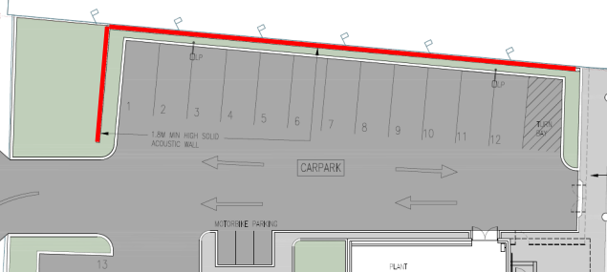

* Any indoor in-house music system can be used if the Sound Pressure Level within the enclosed areas of the club from speakers does not exceed 78 dB(A) at any time.
* The maximum capacity of the patrons within the club (and designated areas) are limited to the following numbers (as shown on current architectural documentation)

- Alfresco Gaming Area: 42 patrons

- Indoor Gaming Area: 34 patrons

- Outdoor Dining Area: 30 patrons

- Alfresco Sports Bar Area: 14 patrons

- Indoor Dining Area: 100 patrons

- Indoor Sports Bar Area: 48 patrons

* Outdoor areas of the club shall not be used for dining and patron occupancy after 10 pm; doors should remain closed while not in use after 10 pm. Compliance during daytime and evening periods should be confirmed by noise testing once operational.
* The final selections and locations of all external mechanical plant and equipment must be made to ensure that the NSW EPA NPfI noise goals (listed in Table 5-1 and Table 5-2) are implemented.

Additionally, specific conditions are to be recommended to ensure the ongoing management of the registered club will not unreasonably impact upon the surrounding amenity.

Based on the location of the proposal it is considered that the waste disposal method will be acceptable provided that delivery times are consistent with the surrounding residents. A condition will be recommended to restrict early morning collection times.

* *Waste Management*

The existing arrangements are to remain as the design is utilising the existing loading dock area adjacent to Warrigal Street with a management plan to be included for its use. This are a will be screened and secured from the street under the proposed works.

The generation of waste by this proposal is anticipated to be acceptable provided that the appropriate services are arranged to collect, handle and transport to a facility which is licensed to receive that material. The manner in which the waste is to be stored prior to collection must be managed so that it does not pollute the environment. Conditions have been recommended.

* *Traffic*

Warrigal Street as a local collector road and Park Road as a local road, both with mainly

residential properties along their length. Based on the environmental capacity thresholds provided within RTA’s Guide to Traffic Generating Developments, the environmental capacity of Warrigal Street is 300 vtph and for Park Road is 200 vtph. Red Buses runs public transport (bus) services in the area. The nearest bus stops are located opposite each other on both sides of Warrigal Street approximately 30 metres west of the site

The traffic assessment prepared by the applicant estimates the site peak traffic generation (based on GFA of 1308m²) to be 79vtph. (Site peak traffic generation = 6 x 1,308 / 100 = 79 vtph). This figure uses a traffic generation rate of 6 vtph which is halfway between the RTA rate of 10vtph and a surveyed rate of a similar club (the Sixteen Footers Club at Belmont) of 3.6vtph.

In estimating traffic generation, the assessment report notes that RTA surveys showed great variation in rates based on location, size, type of club, number of members and facilities within the club and the best way to determine traffic generation is to survey a club itself. This was not possible to do for the club, so the applicant’s assessment (to estimate the likely peak hour traffic generation) was based on the Sixteen Footers Club at Belmont because of a similar location and club attributes.

The report identifies that the local road network is currently operating well within its technical capacity and the addition of another 79 vehicle trips in the AM or PM peak hours, resulting from this development, will not result in the technical or environmental mid-block two way road capacity thresholds being reached.

The report concludes:

* *Current traffic volumes on the local and state road network are below the likely relevant*

*technical two way mid-block capacities of the roads and as such there is spare capacity*

*within the road network to cater for development in the area.*

* *The local and state road network has sufficient spare capacity to cater for the additional development traffic without adversely impacting on current two-way mid-block levels of service (LoS) experienced by motorists on the road network.*
* *Sidra modelling of The Entrance Road / Warrigal Street priority controlled give way Tintersection has shown the development will not have an adverse impact on the operation of this intersection in 2021 and in 2031 with background traffic growth generated by all the developments in the area.*
* *The Warrigal Street / Park Road priority controlled give way T-intersection will continue to operate with uninterrupted flow conditions post development at least until 2031.*
* Context and setting

The site has a history of use as a club dating back to 1939 and is considered to be a suitable use to continue operating within the context of the site. There is no history of complaints regarding noise or other concerns associated with the previous operation of the club on the site.

* *Safer by Design and Tuggerah Lakes Police District*

The applicant prepared a Crime Prevention Through Environmental Design (CPTED) Assessment and an Operation Security Plan of Management for the proposal. The CPTED report has identified a number of recommendations under the 4 CPTED principles which are to be adopted as part of the development including

CCTV along the rear boundary/back of house area and car parks (location plan provided).

On site security and after hours security patrols

Clearly identify the areas that are private / out of bounds.

Maintenance and selection of suitable landscaping

Secure fencing

Installation of ‘Park Smarter’ signage (or similar).

The area (including gardens, hard walls, fencing) should be well maintained. Any evidence of antisocial behaviour (e.g. graffiti, malicious damage, broken lights etc.) should be cleaned / fixed /replaced within 24 hours.

The garbage bin area to be secured and kept out of general sight

Adoption and review of the Operation Security Plan of Management and review.

Additionally, the Licensing Police have reviewed proposal and have raised no objection and agree with the implementation of the recommendations listed within the CPTED report. In particular; 4.1 Territorial re-enforcement, 4.2 Surveillance & 4.3 Access control.” It is noted that in regards to the ongoing management of offensive noise being potentially generated from the use of this proposal the Tuggerah Lakes Police District will be the Appropriate Regulatory Authority for these matters under the regulations for the Liquor License.

Accordingly, it is considered that the proposal will not result in any significant adverse impacts in the locality as outlined above.

* 1. **Section 4.15(1)(c) - Suitability of the site**

The site is considered to be in a suitable context for the nature and type of development proposed being centrally located on a well serviced relatively unconstrained site. Historically, the site has been used as a club since 1939, as such the site is considered an appropriate location for its continued operation as a bowling club. The scale, form, character and density of the development is acceptable within the locality. The proposal is lesser in scale and includes more landscaping and parking than the original building. Under the amended plans provided for the proposal and subject to recommended conditions to address the encroachments, the plinth signage, the parking provision, landscaping and other operational aspects, the proposal is considered suitable for the site.

The design of the proposed development is considered to be in an appropriate form, layout and scale that suitably balances the opportunities and constraints of the site. There are no significant site constraints or hazards that would render the location of the development as unsuitable. There are no matters relating to site suitability that require further consideration or discussion. Subject to recommended conditions the proposal will not adversely impact on the character and amenity of the locality and streetscape.

* 1. **Section 4.15(1)(d) - Public Submissions**

These submissions are considered in Section 4.3 of this report.

* 1. **Section 4.15(1)(e) - Public interest**

**Plan of Management – No. 6 Taylor and Shore Parks, The Entrance**

The site is currently classified as community land rather than operational land and as such is subject to Council’s ‘Plan of Management – No. 6 Taylor and Shore Parks, The Entrance’.

Although, Council has resolved to reclassify and sell the land currently leased by ‘the Greens’ (refer to earlier minutes of Council’s resolution under the History Section of this report), the area remain part of the larger site containing Taylor Park.

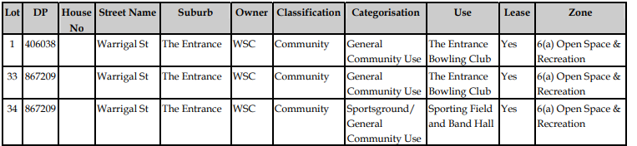

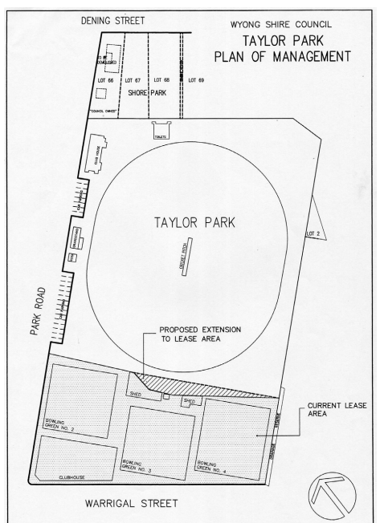 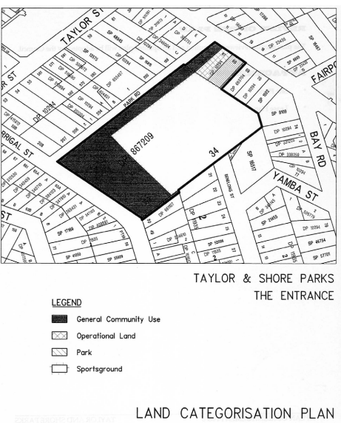

Above: Lease Plan under the POM (left) and Land Categorisation Plan under POM (right)

The adopted Plan of Management (POM) (No.6 – Taylor and Shore Parks, The Entrance therefore currently applies to regulate the use and management of the site. The club leased area is categorised as ‘general community use’ land. The identified objectives for the use of ‘general community use’ land under the adopted Plan include:

*The core objectives for management of community land categorised as general community use are:*

*a To* *promote, encourage and provide for the use of the land, and to provide facilities on the land, to meet the current and future needs of the local community and of the wider public:*

*I In relation to public recreation and the physical, cultural, social and intellectual welfare or development of individual members of the public; and*

*Ii In relation to purposes for which a lease, licence or other estate may be granted in respect of the land (other than the provision of public utilities and works associated with or ancillary to public utilities)*.

In consideration of the above objective some concern was initially raised regarding the internal design of the replacement club. In this regard, a significant proportion of the proposed floor area appeared to be dedicated to gaming activities rather than dining or other community activities. In this regard, it was noted that the original club facilities included a large auditorium and generous dining areas, 4 x bowling greens and associated parking on a larger scale and site than is presently proposed. The current proposal has been reduced to 2 x bowling greens (although now to be covered and made all weather) and a reduced club in size where the dominant use of the floor area appear to be dedicated for gaming purposes.

The applicant has responded to the above concern as follows

*The proposed plans clearly identify the areas of the Club dedicated to gaming, dining, lounge and recreational uses. All of which are community activities that contribute to the enjoyment for the local community. The Club will retain the existing bowling club services such as lawn bowls; two (2) bowling greens existing on the site; dining; lounge; and gaming facilities.*

*The site has always been used as a bowling club and will continue to be used for the same purpose in the redeveloped building. Whilst a bowling green is being replaced with a new carpark, this adds to the benefit of the Club so that its patrons have access to car parking facilities within the site with direct access to the Club’s facilities. The site still provides two (2) bowling greens to continue the lawn bowls recreational use. The bowling greens will be covered by a fabric roof providing weather protection and sun shading. These greens will be able to operate in inclement weather and all year round rather than just seasonally as presently thereby greatly improving the bowling facility and expanding its usability.*

*Lawn bowlers will use the Club’s lounge and dining areas to meet after their games. The removal of the auditorium from the existing Club building was due to this space being underutilised by the Club members. The proposed lounge and dining area will sufficiently provide for the needs of the lawn bowling community. The lounge area will also be used to accommodate solo or two (2) piece bands as entertainment for Club members and their guests.*

*The proposal does not increase the number of gaming machines permitted in the Club under the current liquor licence which has been in place since 12 April 1955. Gaming areas in the existing club building have previous development consent approval and are shown in stamped approved plans since 1974 (refer to DA/1768/74; BA/3366/92; DA DA/2880/99 and DA/1257/2007…). It is evident that gaming machines have existed as part of the Clubs facilities and community activities for many years. DA/1257/2007 approves floor space use for 88 gaming machines. The redeveloped Club will continue to provide 75 gaming machines which is permitted under the Club’s liquor licence. This is less than what was previously provided in the past. The size of the proposed gaming areas is approximately 298m2 and is required to ensure social distancing laws are met, and to provide improved amenity for patrons. Furthermore, the number of gaming machines is not a planning legislative matter and is governed under different legislation. Gaming is considered to be a recreational use and will continue to be provided in the Club as it has been for many years.*

*On this basis, the services and facilities offered by the redeveloped Club remain consistent with the core objectives of the POM. The redevelopment of the Club will continue to provide facilities on the land that have always been there such as lawn bowls, dining and gaming facilities which will continue to meet the physical, cultural and social needs of the community.*

The above arguments are supported and the club proposal is considered to be consistent with the objective to promote, encourage and provide for the use of the land, and to provide facilities on the land, to meet the current and future needs of the local community and of the wider public (which are) in relation to public recreation and the physical, cultural, social and intellectual welfare or development of individual members of the public.

The proposal represents an upgrade to the current recreation facilities on the site albeit on a smaller scale than originally provided. The two bowling greens will be upgraded to be all-weather and the dining facilities and amenities will be upgraded to latest design and construction. There is now a portion of parking spaces provided in very close proximity to the building entry which will assist those less mobile members of the community.

The proposal is considered to be consistent with the adopted Plan of Management for the site subject to recommended conditions. A table of compliance with the POM is attached to the report.

There are no matters associated with the proposal that are contrary to the local or community interest.

1. **REFERRALS AND SUBMISSIONS** 
   1. **Agency Referrals and Concurrence**

The development application has been referred as follows for comment as outlined below in Table 5.

**Table 4: Concurrence and Referrals to agencies**

|  |  |  |  |
| --- | --- | --- | --- |
| **Agency** | **Concurrence/**  **referral trigger** | **Comments**  **(Issue, resolution, conditions)** | **Resolved** |
| Concurrence Requirements (s4.13 of EP&A Act) | | | |
| N/A |  |  |  |
| Referral/Consultation Agencies | | | |
| NSW Police  Force – | Council adopted protocol | Licensing Police raise no objection and agree with the recommendations in the CPTED report. | Y |
| Integrated Development (S 4.46 of the EP&A Act | | | |
| N/A |  |  |  |

* 1. **Council Referrals**

The development application has been referred to various Council officers for technical review as outlined **Table 5.**

**Table 5: Consideration of Council Referrals**

|  |  |  |
| --- | --- | --- |
| **Officer** | **Comments** | **Resolved** |
| Development Engineer | No objection subject to recommended conditions | Yes |
| Traffic Engineer | No objection subject to recommended conditions | Yes |
| Environmental Health Officer | No objection subject to recommended conditions | Yes |
| Food Surveillance Office | No objection subject to recommended conditions | Yes |
| Waste | No objection subject to recommended conditions | Yes |
| Contributions Officer | No objection subject to recommended conditions | Yes |

The outstanding issues raised by Council officers are considered in the Key Issues section of this report.

* 1. **Community Consultation**

The proposal was notified in accordance with the WDCP Chapter 1.2 from 24 September 2021 until 18 October 2021. A total of 1 unique submission raising concerns with the proposal. The issues raised in the submission included the following:

**Table 6: Community Submission**

|  |  |
| --- | --- |
| Concern raised | Applicant response/outcome |
| New car exit via Park Road – direct impacts, narrow residential street, unsafe, more traffic. Request entry only on Park Road with exit and entry on Warrigal Street. | Under the amended plans, the exit to Park Road from the site is now designed to be left turn only and a 1.8m solid acoustic wall with landscape screening is proposed on this part of the frontage. |
| Noise until 2am- unreasonable | The proposed hours of operation have been amended and the Club will operate under their existing hours of operation |
| Parking provision not sufficient for expected patrons. Parking deficiency not acceptable in this location as will impact on too many residences. Park Road residents should be able to enjoy visitors and guest parking in the street.  Current car park to be redeveloped for future housing. No estimates on how high rise or medium density housing will impact on street parking and traffic in park Road.  New development should not be allowed to proceed with an assumption that not providing sufficient onsite parking is still acceptable.  Club redevelopment will be attracting more patrons than previously (regardless of the club’s previous capacity) due to upgraded dining and gambling facilities  The club development should comply now so future problems can be avoided.  Cricket season sees no parking available anywhere in vicinity of site | Additional parking provision will be addressed under the recommended conditions including a deferred commencement conditionrequiring that the  existing club parking on Lots 53, 54 & 55 DP10294 (at 21 Park Road) be retained and used for the new proposed club operations to address the parking shortfall. |
| Car park on Taylor Street not mentioned as will likely be developed for future housing | The Taylor Street parking area is not part of this DA. However, a condition has been included that the existing approved parking on lots 53,54 & 55 in DP.10294 at No 21 Park Road be retained and used to address the shortfall in parking under the application. |
| Traffic impacts - surveys underestimated as during covid and not during peak summer months.  All cars from new carpark must exit via Park Road – unsuitable (as small residential street), dangerous. Request entry only on Park Road and exit Warrigal Street  Intersection of Park Rd and Warrigal Street unsuitable for extra traffic as insufficient width. | The Traffic Consultant for the applicant states:  *Whilst traffic data was collected during the current COVID pandemic, in regard to this development it is relevant to consider that at the time of the counts (21st & 22nd April and 13th May 2021) the Central Coast area was not subject to a COVID lockdown. Further COVID impacts on traffic volumes had most effect during the AM and PM peak periods associated with business hours and school peaks i.e. 8 am – 9 am and 3 pm – 5 pm. The peak traffic period associated with this development will likely be the after work PM period (5 pm – 7 pm) and the weekend lunchtime and evening periods (12 pm – 2 pm and 6 pm – 8 pm). Previous work on similar clubs e.g. Belmont Sailing Club, Kotara Bowling and Recreation club and Lemon Tree Passage Bowling Club by Intersect Traffic has shown that the weekday (Friday) PM peak period has been the critical peak hour for assessment. COVID impacts on this period during non-lockdown hours were not as significant as during the business hours peak periods.*  *Intersect Traffic are of the opinion that pre COVID traffic volumes will not be reached for a number of years in the future as people and businesses become more used to and better set up for on-line shopping and work from home arrangements.*  *Park Road is an 8 metre wide road which provides sufficient width for two way traffic flow and some on-street car parking.* *It is a local road and complies with Central Coast Council’s DCP based on its functional hierarchy as a local road with traffic volumes less than 200 vtph. It is therefore suitable for the car park to have access from particularly as it reduces traffic volumes at the Warrigal Street access where road network traffic volumes are a lot higher than in Warrigal Street.* |
| Noise impacts from gaming and dining – past history of noise impacts from club upon resident sleeping patterns.  *When the club was in operation just having a group of 5-6 people dining outside would cause enough noise from loud conversation, laughing and sometimes fighting to intrude on life in our home. The ability to sleep was affected and became so intrusive that my children would not stay overnight because it became very difficult to sleep in rooms that faced the club.* | Amended acoustic report has been prepared which includes a number of recommendations. One of these requires a 1.8m high solid acoustic wall will be installed to the northern section of the proposed carpark facing Park Road. The measures to address acoustic impacts of the proposal are considered satisfactory subject to recommended conditions. |
| Noise from 54 patrons in a proposed Outdoor Sports Bar and Dining Area and an additional 42 patrons in the Outdoor Gaming Area will be significantly increased. Operating these until 10pm for 7 days a week is not fair to local residents. Machines and patrons drinking alcohol until 2am is not going to be quiet. These areas should not operate beyond 9pm.  *Having these areas open until 10pm and the doors open is not fair to local residents. The latest the outdoor areas should operate Sunday – Thursday should be 9pm.* | The measures to address acoustic impacts of the proposal are considered satisfactory subject to recommended conditions. |
| Existing club intermittent noise from outdoor doors opening and closing when patrons would exit and enter the building resulted in very intrusive noise from music or PA announcements which was bad enough but current proposal will leave door open until 10pm, 7 nights a week which is unreasonable as loud music, PA systems and general noise from patrons will be heard by local residents every week night until 10pm  Increased noise from patrons leaving the club late at night with the closer carpark to residents and with finish time at 2am every night | The Clubs trading hours will continue to operate under the same trading hours for the existing club. The Clubs trading hours will operate until 12.30am. The recommendations within the Acoustic Assessment Report are ot be adopted as part of the development in addition to further recommended conditions. |
| Owned house for more than 40 years and the current proposal will adversely affect residents by reducing street parking, increasing traffic, increasing noise and affecting ability to sleep | The proposal is considered satisfactory subject to recommended conditions to address noise, parking, and amenity. |

The amended plans for the proposal were notified in accordance with the DCP from 11 February 2022 until 25 February 2022. The amended plans also included 10 Warrigal Street as part of the application. No submissions were received from the renotification of the application.

1. **KEY ISSUES**

The following initial issues were raised in relation to the assessment of this application having considered the relevant planning controls and the proposal in detail:

|  |  |  |
| --- | --- | --- |
| Issue | Applicant’s response and discussion | Resolved |
| Plan of Management – demonstrate consistent | Under the amended plans there is no change to dining and gaming areas on plans. However, the applicant has advised:  *The proposed plans clearly identify the areas of the Club dedicated to gaming, dining, lounge and recreational uses. All of which are community activities that contribute to the enjoyment for the local community. The Club will retain the existing bowling club services such as lawn bowls; two (2) bowling greens existing on the site; dining; lounge; and gaming facilities.*  This is further discussed earlier in this report.  Further the applicant states:  *As recorded in the Taylor Park plan of management, The Entrance bowling club was formed in 1939. Please read page 4 of the 2018 financial report attached. It clearly indicates that the club was in financial distress and membership was declining. Page 4 also illustrates that it was the club’s desire to continue the primary activity of the bowling club by providing amenities that ensured the financial and future viability of the company.*  *The members notice provides endorsement that MLG is the vehicle to continue the bowling club’s objectives..this demonstrates that the building is suitably designed for the purpose of providing a bowling club to continue serving the community as has been intended for 80 years.*  The applicant also argues the proposal is for the continued use of the site as a bowling club.  The site still provides two (2) bowling greens to continue the lawn bowls recreational use and the provision of closer parking for patrons. The bowling greens will be covered by a fabric roof providing weather protection and sun shading, thereby greatly improving the bowling facility and expanding its usability. Gaming activities have taken place on the site since 1974 and machines reduced from 88 to 77 machines under proposal and larger area needed for social distancing for gamers.  The applicant argues that the removal of the auditorium from the existing Club building was due to this space being underutilised by the Club members. The proposed lounge and dining area will sufficiently provide for the needs of the lawn bowling community. The lounge area will also be used to accommodate solo or two (2) piece bands as entertainment for Club members and their guests.  On this basis, the services and facilities offered by the redeveloped Club remain consistent with the core objectives of the POM. | Yes |
| POM – Energy efficiency (p.12) | The building has been designed to comply with Section J under the Building Code of Australia. The applicant has provided a NCC 2019 Section J Report prepared by BCA Energy. | Yes |
| Car parking provision –substantial shortfall not addressed. Concerns raised. Query why existing approved spaces on the western side of Park Road aren’t included under the proposal to address the shortfall? | Under the amended plans an additional 30 spaces have been provided with the inclusion of the existing parking at 10 Warrigal Street. This increases parking provision to 67 spaces. This is still 51 spaces less than the required 118 spaces required for the club under the DCP and does not further consider the 45 spaces required for the bowling greens.  The applicant has advised the club will not be providing a courtesy bus service to address the shortfall as it is not feasible and uber and taxi’s are available.  Additionally, the lots at 21 Park Road accommodate the current approved parking for the previously approved club on the site. Were this parking to remain in place to service the new club operations, the issue of the parking shortfall would reasonably be considered as resolved and the parking provision for the club be satisfactory.  The issue of parking shortfall is further discussed under the DCP section of the report. | No but can be addressed under recommended conditions |
| Carpark design conflicts and non compliances with AS/NZS 2890.1- needs revising | The Park Road access is now revised from 2-way to be ‘exit left turn only’ and moved slightly to the south. Conversion of one parking space as a turnaround bay for the dead end aisle has been made on the northern boundary. Narrowing the landscaped strip along Park Road to allow a slightly wider pathway and landscaped strip adjacent to the building to better accommodate accessible parking. | Yes subject to recommended conditions |
| Social impacts- lack of local community engagement. | The applicant’s consultant Aigis Group states in relation to Community engagement on Page2: *It was decided that given the longstanding presence of the club at its location, and that the restored club would essentially resume operations on an essentially similar basis as prior to its enforced closure, additional direct engagement with the immediate community was unnecessary.*  The SIA engagement was *substantially based on material provided by MLG and ADW Johnson, which established that a significant level of engagement activity had already been undertaken, in relation to future use and ownership of the site, and reestablishment of club operations.*  This consultation included:   * Council’s consultation period for the asset sales program * *A number of Community Advisory Committee meetings held for The Greens at The Entrance since amalgamation in September 2019. The committee is made up of Mingara Leisure Group Executive members and now ex The Greens Board members*. The committee was *established to deal with matters relating to the currently addressed redevelopment, and MLG’s purchase of the club site from CCC*. * Council’s notification for reclassifying the site from community to operational land.   Not withstanding this, the application has been notified on two separate occasions and the one submission that was received has been discussed earlier in the report. It is considered that the matters raised in the submission have been suitably addressed under the amended plans and recommended conditions. | Yes |
| Clarification of the proposed works under the application- plans do not clearly depict the existing versus retained parts of building. Substantial part of building demolished and remainder of club building approved for demolition. Clarification as to proposed works and the viability and suitability of retaining the remaining street façade | A structural engineering statement (email from Northrop Consulting Engineers dated 21.12.21) has been provided stating:  *We understand that the existing structural steel roof and wall members are being retained, with only secondary framig (sic) including purlins, fascias and roof sheeting being removed and replaced. This is a like-for-like replacement with with (sic) new roof materials not to exceed the roof weight/load of the original design. This means the original design will still be structurally adequate.*  *The external wall, consisting of 2 skins of brickwork which has been retained from the original building, are non-loading bearing brickwalls. During demolition, we were engaged to provide additional measures to ensure these walls had sufficient restraint for the temporary construction period until the new building is constructed. At this point, the walls perform effectively the deterioration can occur within the cavity brick ties overtime. This can be investigated by the builder and rectified as required.*  The information provided clarifies the works and verifies its structural integrity. | Yes |
| Appearance of elevations – Warrigal elevation – existing retained elevation zero setback and visually unappealing. Waste area facing street front. Photomontages do not clearly depict | Further plans and a photomontage have been provided with the amended information.  The applicant has advised:  *The width of the opening to the BOH area off Warrigal Street has been significantly reduced to what is existing and the sliding screen will be provided with a solid backing material to further reduce noise generated from this area*.  The proposal will present an upgrade of the building and facilities from those that previously operated on the site. | Yes |
| Lighting concerns – overspill associated with car park headlights and LED signage | Under the amended information the hours of operation are to remain unchanged.  The proposed 2-way access to Park Road has now been revised to an exit only left turn to Park Road. And a 1.8m high solid acoustic wall will be installed to the northern section of the proposed carpark facing Park Road to address headlight glare. The driveway is positioned so it is not directly opposite any residential properties in Park Road.  The applicant has advised:  *The carpark lighting has been designed to comply with the relevant Australian Standards (AS1158.3.1-2020 and AS4282-2019) as shown in the carpark lighting plan. The illuminance and luminous intensity levels of the proposed carpark’s lighting at the adjoining boundaries to the site passes the allowable illuminance levels for outdoor lighting.*  *A qualified expert has assessed the illumination levels of the proposed LED sign in the submitted ‘LED Signage Assessment Report’ prepared by Webb Australia Group (NSW) Pty Ltd.*  *The LED sign illumination levels achieve compliance with SEPP 64 and AS4282:2019. The LED sign has the in-built capability to be programmed and automatically dimmed based on the ambient light levels to achieve compliance to SEPP 64.*  *The LED screen does not directly face into any nearby residences. Based on the above expert report, the LED sign illuminance levels can be controlled to minimize obtrusive light spill to neighbouring properties.* | Yes, subject to recommended conditions |
| Acoustic concerns -parking, plant and operation up to 2am with congregational noise | *An amended Acoustic Assessment Report has been provided and**now includes the receiver at 12 Warrigal Street. Operational noise, and sleep disturbance is addressed in the report.*  *A 1.8m high solid acoustic wall will be installed to the northern section of the proposed carpark facing Park Road. The wall return within the Park Road setback will be heavily landscaped as shown on the proposed landscape plans to soften the solidness of this wall and maintain streetscape amenity*.  Council’s Senior Environmental Protection Officer has assessed the amended plans and information and has supported the application subject to specific recommended conditions. | Yes, subject to recommended conditions |
| Revised CIV for amended proposal | A revised costing was provided with an increased CIV. Additional fees have been paid and the contributions have been revised. | Yes |
| Clarification of northern gaming area on plan | The northern gaming area design is described as partially ‘open’ at ceiling level with no horizontal openings in the walls.  The section drawings identify the ‘open’ sections at ceiling level which is between the gaming room and plant room. These open sections are fixed louvres as required for smoking legislation in clubs. Rain will be captured by internal drainage systems which are also landscaped as shown in the landscape plans.  Council’s Senior Environmental Protection Officer has assessed the amended plans and information and has supported the application subject to specific recommended conditions. | Yes, subject to recommended conditions |
| Location and design of existing waste storage/collection arrangements – unsuitable for new proposal. Investigate an alternative location. Provide further details regarding the viability and suitability of retaining the present waste area. | The applicant has advised:  *The redevelopment of the club is retaining the single storey portion of the club building located on the eastern side of the site. This retained portion of the building retains the existing loading and waste storage areas.* *An alternative arrangement is not possible and is not feasible…*  *The proposal is providing alterations and additions to the existing building and is retaining the existing loading zone on Warrigal Street and waste storage area.*  *The retention of the existing remaining facades are a sustainable approach to development noting they are structurally adequate and are able to be re-used and integrated into the new building form.* | Yes |
| Revised Waste Management Plan required | A revised Waste Management Plan including a BOH plan indicating number, type and size of bins provided.  No vehicles will enter the BOH area from Warrigal Street to collect waste bins. All waste is collected from the kerb-side in the existing loading zone area on Warrigal Street. | Yes, subject to recommended conditions |
| Impact of LED signage plinth – oversized for residential location and site context, visual amenity impacts and light spill impacts on residential activities.  A reduced and more human scale and size needed and reduce size of LED panels with preference for signage that does not involve a large display area for changing messages. | There has been no change to the size or scale of the signage and no reduction in size of the large LED display area. Rather, a plan comparing current signage to proposed signage provided. The applicant has argued:  *The face area of the proposed LED sign is larger than the existing, but is also set back behind the boundary line within a landscaped setting. The proposed signage plinth and LED screen is a combination of building identification, information and advertising signage. Mingara Leisure Group have confirmed the LED sign will be static with image changes every 30 seconds.*  *The proposed signage has been addressed against the relevant requirements of SEPP 64 and is considered to meet the objectives of Clause 3(1)(a) and the Schedule 1 Assessment Criteria. The sign is well below the building height limit of 12m in the adjoining R3 zone and commensurate with the immediate context and existing low density residential character of the area.*  This matter is discussed in detail earlier in the report and subject to recommended conditions including a reduction in the scale of the LED plinth sign and other operational measures, the proposal is considered satisfactory. | Yes, subject to recommended conditions |
| Servicing/Delivery hours | *Deliveries and waste servicing will be carried out between 7am to 3pm Monday to Friday.* | Yes |
| Hours of operation reasons for the proposed changes  Identify existing approved hours of operation for cub | The hours not changing from the current operating hours.  The applicant advised:  *A search of Council records in relation to approvals granted on the subject site in relation to the bowling club use was carried out. No information verified the historic approved hours of operation on any development consents issued by Council.*  *The existing Club has been operating under the following trading hours which are the consistent with the trading hours under the liquor licence*:  Trading Hours:  Monday to Saturday – 9.00am to 12.30am.  Sunday – 9.00am to 11.00pm.  Liquor Licence Trading Hours:  Monday to Saturday – 5.00am to 12.30am.  Sunday – 5.00am to 11.00pm.  The liquor licence allows gaming to operate between 8.00am to 2.00am. However, gaming does not operate until 2.00am as trading is only permitted to 12.30am.  Applicant has now advised there will be no change to the existing trading hours of operation which are:   * Monday to Saturday – 9.00am to 12.30am. * Sunday – 9.00am to 11.00pm.   There will be no change to the current operational hours within the redeveloped club. | Yes |
| Encroachments   * of the building (eave) into Council's road reserve area in Warrigal Street * of the development (existing green) into the road reserve area in Warrigal Street * of the carpark at 10 Warrigal Street into 2-4 Park Road. * a portion of Park Road is constructed within the boundary of 2-4 Park Road. | The applicant has responded:  *To address the encroachments in Warrigal St, a Plan of Easements and Positive Covenant within Road has been lodged at LRS Office for registration. Plan now known as DP 1285777.*  *To address the encroachment in Park Rd, a Plan of Subdivision dedicating Road has now been lodged at LRS Office for registration. Plan now known as DP 1285833*  *…the car park at No. 10 Warrigal Street has been used as a carpark in relation to the Club’s use at 2-4 Park Road for over 40 years…* *There is an existing retaining wall that is shown in DP 406038 which is extends into the road reserve. The car park surface meets this retaining wall. The encroachment does not contain a building or structure and is merely a surface encroachment and line marking for car spaces.*  The applicant has advised that an *easement is to be created over the Warrigal Street encroachment. This will occur outside the DA process and will resolve the encroachment matter.*  It is understood that an easement has been created by Council’s Property Section for the encroachment of the structure over Lot 50 DP.661107 at No.10 Warrigal Street.  Deferred commencement conditions will be included under the recommended conditions which do not permit an operational consent until the above plans have been registered with NSW Land Registry addressing the encroachments. | Yes subject to recommended deferred commencement conditions |
| Further details of food and drink areas | Plans relating to food and beverage areas are provided. | Yes |
| Panel minutes issues: | | |
| * Clarification existing versus the proposed development. Further details and colour coding | Revised plans have been provided clarifying the proposed development versus the existing retained development. The up to date aerial photos also clarify this arrangement on site. | Yes |
| * Removal of the auditorium facility and the impact on community gathering points. | The applicant has advised:  *The removal of the auditorium from the existing Club building was due to this space being underutilised by the Club members. The proposed lounge and dining area will sufficiently provide for the needs of the lawn bowling community. The lounge area will also be used to accommodate solo or two (2) piece bands as entertainment for Club members and their guests.*  As stated earlier *the club was in financial distress and membership was declining… it was the club’s desire to continue the primary activity of the bowling club by providing amenities that ensured the financial and future viability of the company. The members notice provides endorsement that MLG is the vehicle to continue the bowling club’s objectives.* | Yes |
| * Carparking interface with Taylor Park at grade with no retaining walls. Finished levels and cross-sections to be provided. | The applicant has advised:  *The existing RLs will be retained including the existing retaining wall which becomes fairly substantial at the eastern end of the proposed carpark where there is an existing drainage inlet from the oval.*  The applicant has provided 3D image plans which show this interface however, no plan sections with levels were provided. | Satisfactory for the assessment |
| * Plan of Management to consider additional acoustic and noise mitigation measures for the extension of operation to 2am to surrounding residential developments. | No longer applicable as the hours of operation remain unchanged under the latest revised proposal. | Yes |
| * Acoustic report to identify dwelling at No. 12 Warrigal Street as a noise receiver. | The Acoustic Assessment Report now includes the receiver at 12 Warrigal Street. | Yes |
| * Landscaping. | Landscaping plans were originally provided with the DA submission and they have been further updated with the amended plans and information.  However, the planting plan does not show where the species listed on the schedule are to be planted on the site. | Yes, subject to recommended conditions |

1. **CONCLUSION**

This development application has been considered in accordance with the requirements of the EP&A Act and the Regulations as outlined in this report. Following a thorough assessment of the relevant planning controls, issues raised in the submission and the key issues identified in this report, it is considered that the application can be supported subject to recommended deferred commencement conditions to address the boundary encroachments, parking provision, illuminated signage and landscaping and other specific conditions to address acoustic and other amenity impacts, safety and security, waste management and various operational aspects.

Specifically, the recommended deferred commencement conditions will address the following aspects:

* Register a caveat or equivalent to link the site containing parking (at 10 Warrigal Street and to the site Lots 53, 54 & 55 at 21 Park Road) to the site on which the new club is located. Additionally, plans outlining the existing approved parking located opposite the site on Lots 53, 54 & 55 at 21 Park Road for the use as part of the new club operations (to address the parking shortfall).
* Registration at NSW Land Registry of the linen plan addressing the encroachments
* Reduction in the scale of the illuminated plinth sign to reduce the adverse impact on surrounding residential amenity and better fit in the site context
* Revise the landscape plan to clearly show what species are being planted where on the site

It is considered that the key issues as outlined in Section 6 have been resolved satisfactorily through amendments to the proposal and/or in the recommended draft conditions at **Attachment A**.

1. **RECOMMENDATION**

That the Development Application DA No DA/1163/2021 for redevelopment of the existing fire damaged Registered Club and associated works at 2-4 Park Road, The Entrance, Lot 1 DP 180642, Lot 1 DP 406038, and 10 Warrigal Street, The Entrance, Lot 50 DP 661107be APPROVED pursuant to Section 4.16(1)(a) or (b) of the *Environmental Planning and Assessment Act 1979* subject to the draft conditions of consent / reasons for refusal attached to this report at Attachment A.

The following attachments are provided:

* Attachment A: Draft Conditions of consent
* Attachment B: Tables of Compliance
* Attachment C: Architectural Plans: